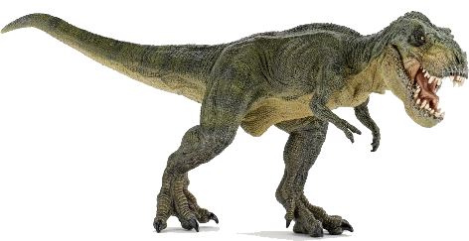
Dear Year 3 parents and carers,

The Year three children and teaching staff invite you to attend our ‘Pop-up dinosaur museum’ on Wednesday 25th October from 3:00 to 3:20, in the J1 and J2 classrooms. Children have been working extremely hard to produce some brilliant pieces of writing and art work showing off their understanding of dinosaurs and the habitats in the prehistoric age.
We look forward to seeing your there.
Thanks again for your support.

The Y3 team
Mr. Beauchamp, Mr. Jenkins, Mr. Allen, Mr. Fairweather, Mrs. Walton, Mrs. Wales and Mrs. Mather

