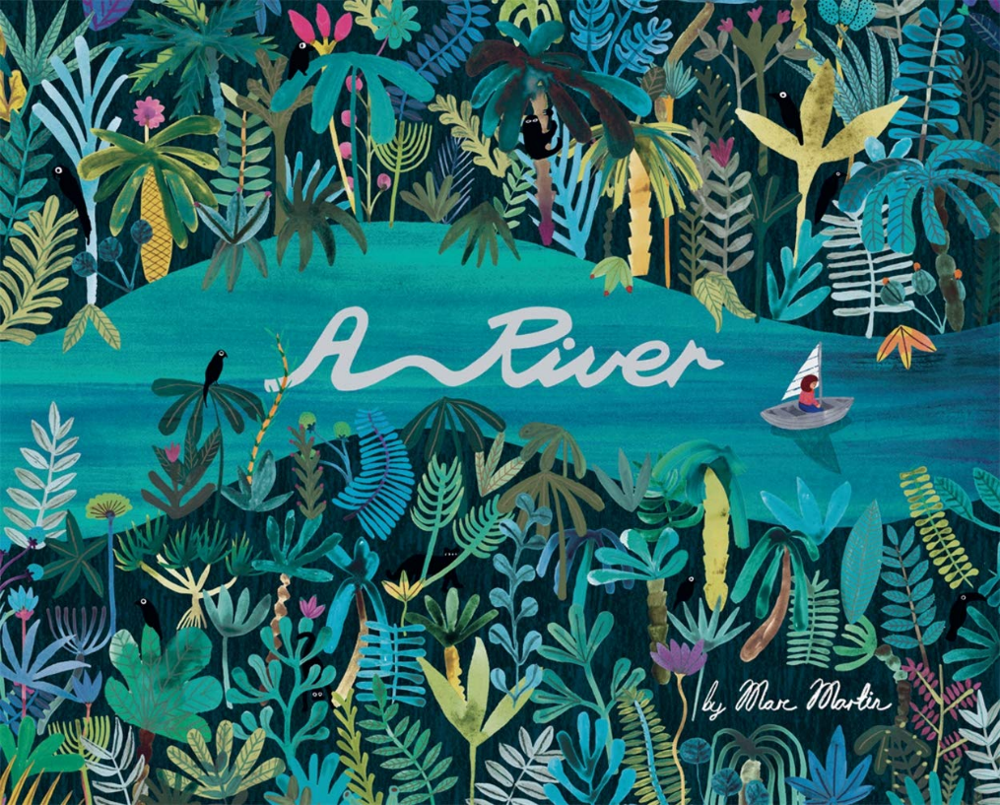

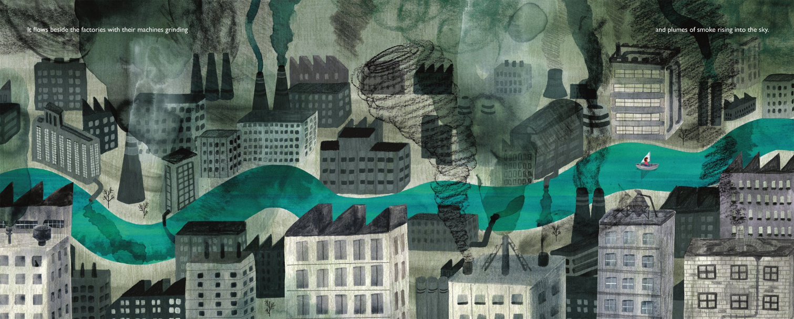
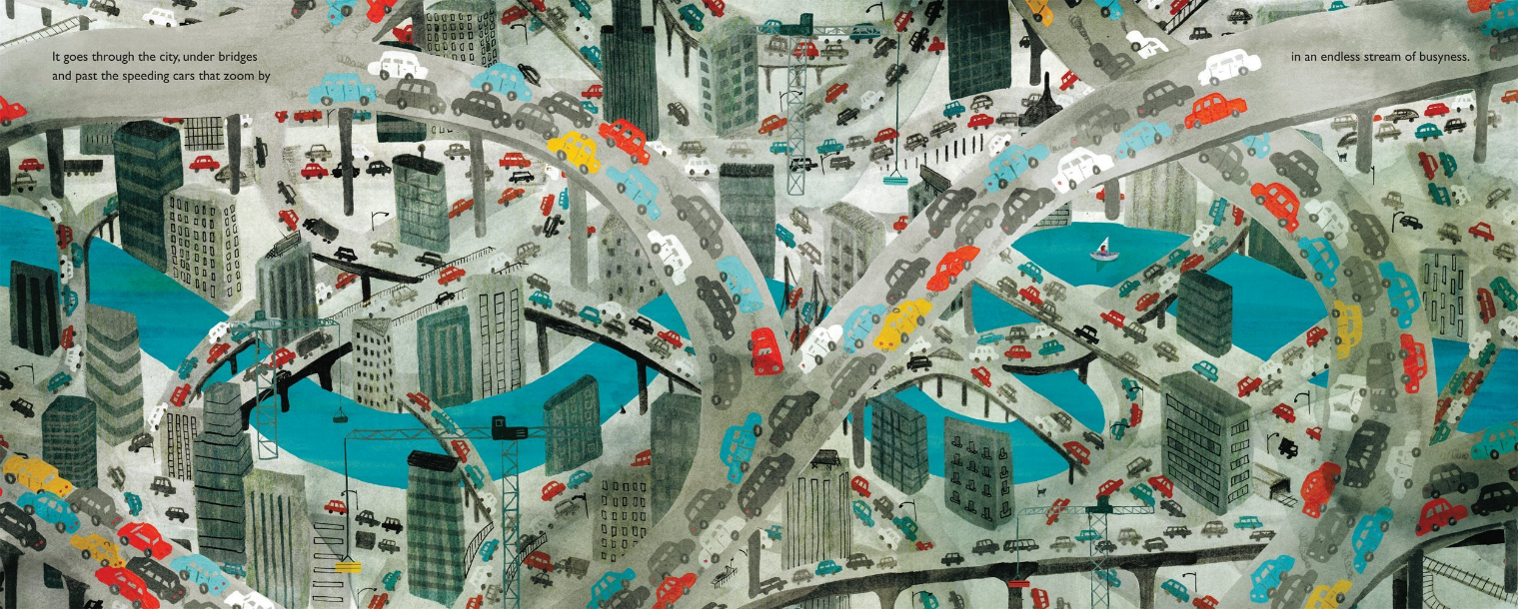
Theme – Why are rivers important to people?
Study the images above from A River by Marc Martin. Think carefully about how rivers are used by humans, and how they may appear as the landscape around them changes.
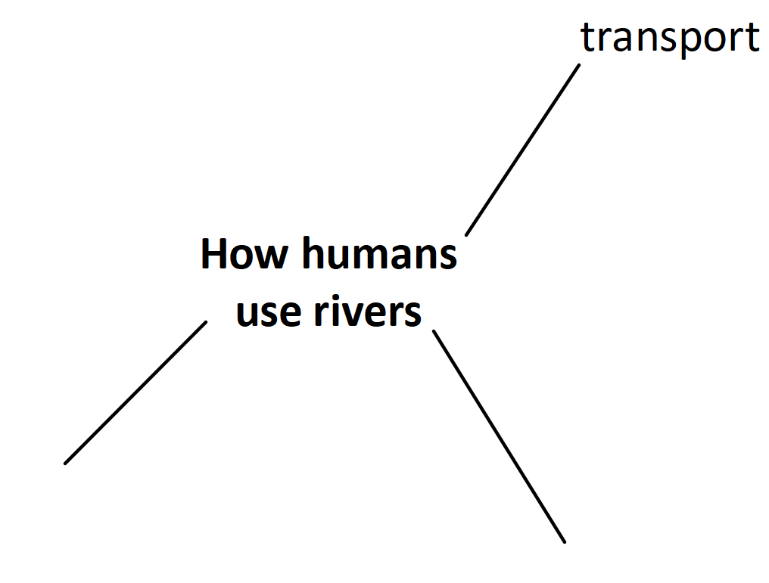
Retrieval: recap the different uses for rivers.

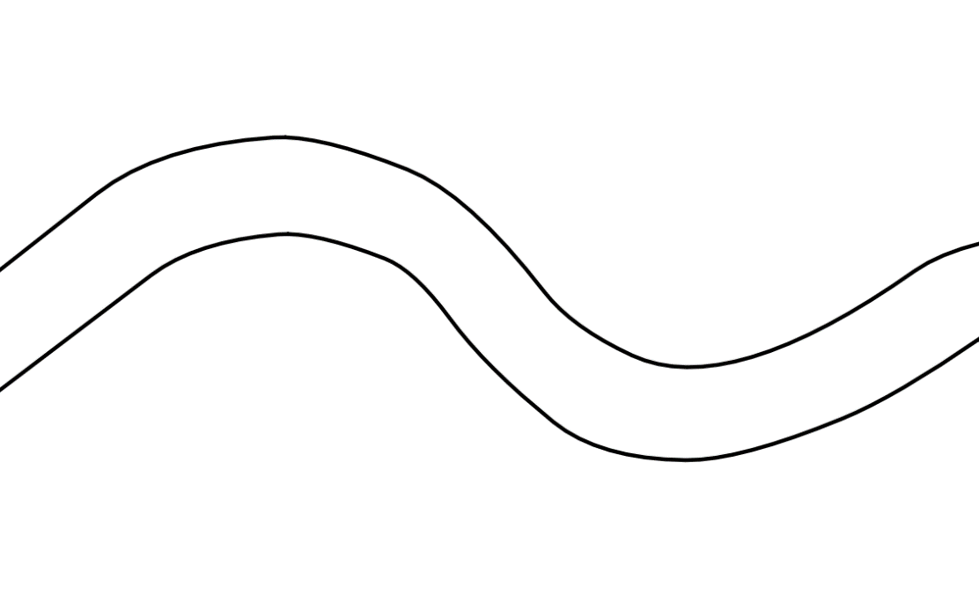
On a blank sheet of A4 paper, draw two symmetrical lines to form the outline of your river. Using whatever drawing materials you have to hand, e.g. coloured pencils, paint, felt tips, shade in your river. If you do not have any of these at home, shade in your river using pencil. You are aiming to make the colour as vibrant and even as possible.

Choose a setting for your river. It could be running through the Amazon Rainforest, the English countryside or a busy city centre. Look again at the images from the book and ask yourself what details you could add to your river to really bring it to life.
You can use whatever materials you have to hand to finish your artwork. Detail is key! Think carefully about trees and plants if your setting is a rural one; if you are basing your artwork somewhere urban like a city, think about buildings, roads and vehicles. Are there any humans or animals that could feature in your artwork? Try to fill the space as effectively as possible – take your time and don’t rush!

