Y5 H0-H0-Home Learning
Out – Wednesday 12th December
Back in – Tuesday 18th December
Welcome to a festive edition of Y5 Ho-Ho-Home Learning. To begin with, have a go at this cracker of a Christmas challenge.
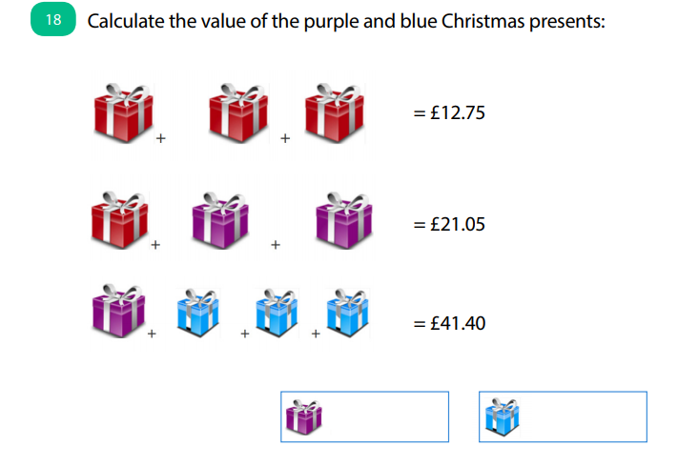

Still hungry for more? Can you create a similar Christmas themed maths problem using these three images you might buy in the supermarket?
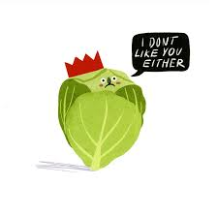

Macbeth has a Festive Favour
It’s a busy time of year in Inverness too. Macbeth has been up to his neck with his Christmas cards. He is so busy being King that he hasn’t had time to write his annual card to his distant relatives (to whom Shakespeare made no reference in the play) who live in Hawaii. Can you help dear old Macbeth out and write a card to his faraway family telling them all about his very eventful year?



