Y5 Home Learning
Out – Wednesday 19th September
Back in - Tuesday 25th September
Complete the following multiplication and division quiz as quickly as you can. Record the time it took you here:___________
Can you beat this next time we do a quiz like this?
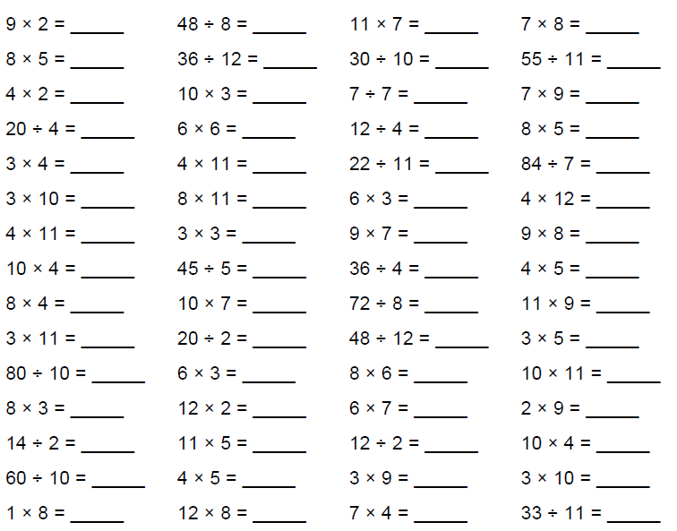
Knowing your multiplication tables and the inverse division facts is a key instant recall fact (KIRF) that is vital to accessing nearly all maths in Y5 and beyond.
If there is a particular area of this quiz you have found challenging, then work on this to increase your knowledge in this area. Try reciting the tables in the car, doing them in your head as you brush your teeth, getting an adult to randomly fire questions at you out of the blue or any other way that you find helps.

Writing
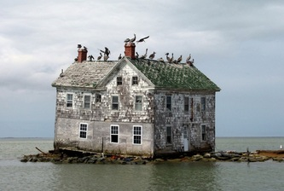
Write a paragraph describing this image. Use expanded noun phrases and ambitious vocabulary to bring the image to life and add detail.

What a Good One Looks Like (WAGOLL)
The fading, stone-built house stood almost abandoned. Surrounded by murky, green water, the only life in the house was that of the birds which now called this decaying, unstable wreck their home.
__________________________________________________________________________________________________________________________________________________________________________________________________________________________________________________________________________________________________________________________________________________________________________________________________________________________________________________________________________________________________________________________________________
____________________________________________________________________________________________________________________

