Year 3 home-learning
Name:
Sent out: Wednesday 8th May
Home-learning due: Friday 17th May
Claim your 2 gems when you hand in your completed home learning!
Task | Notes | Tick off when completed, and return to your teacher by Friday 17th May. Don’t forget your gems!
Read 10 times to an adult over the two week period | Bring the signed bookmark to your teacher to be signed off and placed in the bookmarks raffle box. There are books to be won!
Complete the division facts challenge | Calculate the division questions linked to the 2,3,4 and 8 times table.
Home spellings | Select and learn between four and ten words from the Y3/4 word list (previously sent home and on the Y3 section of the school web site) at home using the look, say, cover, write, check practice sheet.  Please note that some children who are at a different stage of their spelling development, will be given alternative spellings to learn.
Complete any Maths No Problem practice worksheets that are sent home during this period | We will occasionally send home maths practice worksheets from our learning in school. These are a great way to reinforce the learning your child has done in class. Please encourage them to do as much as they can independently – or even better, to teach you how to do it!
Parents and carers, please comment about your child’s home-learning successes and challenges:

Please ask your child’s class teacher if you have any further question about these tasks.

Home Spellings
Over the next two-week period, you will be continue practising the Year 3 spellings.
Use the Year 3/4 spelling lists to select and practise up to 10 spellings. A friend will test you in a few weeks to see if you can remember them! The list was sent home last term, but if you need another copy please download them from the Y3 section of the school website.
1. | 2. | 3. | 4. | 5.
6. | 7. | 8. | 9. | 10.

Find out the meaning of each of these words. Can you use them in a sentence (spoken and written)?
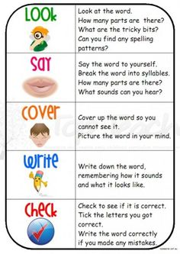

Spellings to practise
Use this space below to practise your year 3 3 spellings. Remember to look, say, cover, write, check. Do this four times for each word that you learn.
Write your spellings in here | 1st Attempt | 2nd Attempt | 3rd Attempt | 4th Attempt
1.
2.
3.
4.
5.
6.
7.
8.
9.
10.

Use each spelling in a sentence:
1._______________________________________________________________
2._______________________________________________________________
3. ______________________________________________________________
4. ______________________________________________________________

Maths - Division facts for times tables
Strategy: To solve 20÷4
Count up in multiples of 4s in your head, on your fingers or on a number line until you get to 20: 4,8,12,16,20. How many multiples did you count? 5. So 20÷4 = 5. Check it works by using the inverse: 5 x 4 = 20. Yes! Let’s practise…
