Teaching and Learning Bulletin |  |  | January 2019  Volume 1, Issue 3
Hunter’s Bar Junior School
Your 2018-19 CPD Tool-kit now includes…  - Reducing students’ cognitive load in the class room.  - Using interleaved and spaced-out low stakes testing to strengthen pupils’ recall of knowledge.  - Planning and using Knowledge Organisers.  - Using live modelling in writing lessons to articulate success.  - Ways to deepen early graspers’ understanding in Maths.  Who to follow on Twitter: @tombennet71  Teacher, author and TES writer, Tom is probably the most creative writer on Twitter. Co-founder of @ResearchEd1, shifting academic research into classrooms. Lots of practical ideas to use in the classroom.  Contents  1. Resource of the Week  2. SDIP priorities  3. ‘15 minute forums’  4. Book study and TLC  5. Upcoming CPD  6. Staff voice | A Happy New Year to all staff!  Take charge of improving your own practice!  Make use of this regular bulletin, filled with current and relevant information for all staff at Hunter’s Bar Junior School.
3. 15 minute forums
2. SDIP Priorities 2018-19
1. Resource of the Week
 | 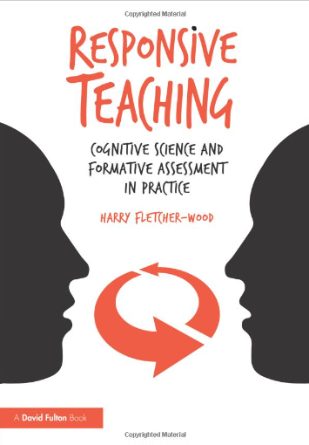  This half term, through our TLCs, we will be exploring how we use models and examples to help students improve their standard of writing.  We will become more adept at showing our pupils what success looks like in writing.  Make sure you use David’s Deepening task resource to help plan for and extend our early graspers in the In Focus task in your Maths lessons. See Dave for any additional support in using them effectively.  4. Book study and TLCs | Each Wednesday this half term.  9/1/19 TLC#3 Showing success through the use of models  16/1/19 Inclusion: Using the Sheffield Support Grid  23/1/19 Launching Wellbeing for staff and pupils  30/1/19 EPIC Curriculum: Pupil voice - Following pupils’ lines of enquiry  31/1/19 Twilight - Launching the HBJS vocabulary model  6/2/19 Maths – Reviewing current deepening strategies and looking further at differentiation  13/2/19 EPIC curriculum: Reflection (flexible timing)  5. Forthcoming Professional Learning  - Developing and embedding effective writing pedagogy  - Developing and embedding talk/vocabulary across the curriculum  - Implementing a Maths mastery curriculum through the MNP approach  - Wellbeing for pupils and staff | “The element of CPD that has had the most impact on my teaching recently has been reducing cognitive load. Research on short and long-term memory has enabled me to understand how learning key facts in Maths, for example, frees up space in short-term memory allowing greater focus on the problem to be solved. Revisiting learning at least three times, referring to previous work in books and using examples on the working wall are some of the ways cognitive load has been reduced, which have had an impact on pupil outcomes. “  Jackie  Coming soon…  Weekly and 100% voluntary 15 minute CPD sessions run after school from 3:35 to 3:50.  Sesison1 - How to conduct running records.  Session 2 - PM bench-marking.  6. Staff voice – Jackie Bridges
For further clarification on any of the points addressed in this bulletin, please see Alex.
If you would like to contribute to this T and L bulletin, please contact Alex.

