Year 4 Home-learning week 3
Home-learning set: Wednesday 22nd November 2017
Home-learning due: Wednesday 6th December 2017
Dear Parents, carers and Y4 learners,
Children will be expected to complete the following tasks over the next two-week period:
Task | Notes | Tick off when completed, and return to your teacher by Wednesday 22nd November
Read 12 times to an adult | Bring the bookmark to your teacher to be signed off and placed in the bookmarks raffle box.
Complete 2 times table zappers | Bring the completed zapper to your teacher to be signed off and placed in the zappers box.
2+ MyMaths tasks (PC/ tablet/ home-learning club in school) | Refer to recent letters how to access MyMaths. Use the login details provided. The online work will be monitored and adapted by the class teacher. If children cannot access the work online, they will be offered time in school to complete it.
Learn your spellings | Your spellings for this fortnight are:  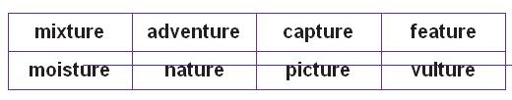  What sound do these letters make at the end of a word? Can you think of any other examples?

Parent comment about your child’s home-learning success:

