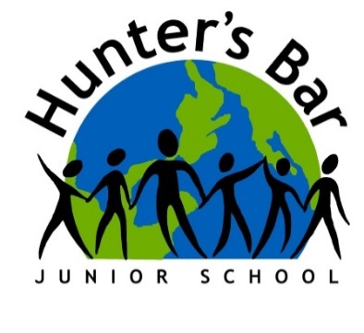

Dear Parents / Carers,
To celebrate the Y6 children’s time at Hunter’s Bar Junior School and their success in Year 6, the children will be putting on a leavers’ performance – ‘The Greatest Show on Earth”. There will be three performances of The Greatest Show on Earth which parents, carers, family and friends are invited to come and enjoy: Monday 8th July 13:30 ,Wednesday 10th July 13:30, and 18:00.
Each performance will last approximately one hour and will be held in the school hall. Tickets are £2 each with all funds to be used for the Year Six end of year disco the following week. They will be limited (initially) to two per child to ensure all children have the opportunity to bring family and friends to watch. If there is capacity to release more tickets, then we will contact you about this. Tickets will be allocated on a first-come-first-served basis so please purchase on sQuid promptly to ensure you get tickets to the performance you desire.
Please return the attached form to let us know if your child can perform on Wednesday 10th at 18.00.
We look forward to seeing you there.
Mr Preston, Mrs Stockley, Mrs Amin and Mr Hurley
PLEASE FILL IN AND RETURN THIS SECTION REGARDLESS OF IF YOU REQUIRE TICKETS:
Childs name …………………………………………………………………………………………………..
My child will / will not be able to attend the evening performance on Wednesday 10th July 18:00
My child will be collected at 19:30 by contact no: .
My child is walking home unaccompanied □ signed .

