Y5 Home Learning
Out – Wednesday 28st November
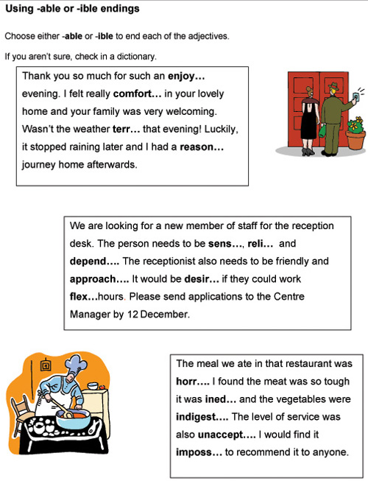
Back in – Tuesday 4th December
Remember the top tips:
- able is more common than ible
- the able ending usually (but not always) comes after a complete root word can be heard.
- The able ending is often used if there is a related word ending in ation e.g. applicable / application.

Maths – KIRFS (Key Instant Recall Facts)
Knowing all 12 multiplication tables and their inverse division facts is a vital skill to be a successful Y5 mathematician. Complete this puzzle to help keep your skills sharp.
