Year 3 home-learning
Name:
Sent out: Wednesday 7th November
Home-learning due: Friday 21st November
Dear Parents, Carers and Y3 learners,
Children will now be encouraged to complete the following tasks at home over the period given above:
Task | Notes | Tick off when completed, and return to your teacher by Friday 26th October
Read 10 times to an adult | Bring the bookmark to your teacher to be signed off and placed in the bookmarks raffle box.
Practice 5 times table and complete 5 times table quiz | Our target is to be confident with our 2, 5, 10, 3, 4, and 8 times tables by the end of the year. Quick-fire daily practice is an important part of securing these key skills. Online games and apps are a great way to practise!
Complete any maths practice worksheets that are sent home during this period | We will occasionally send home maths practice worksheets from our learning in school. These are a great way to reinforce the learning your child has done in class. Please encourage them to do as much as they can independently – or even better, to teach you how to do it!
Home spellings | All children will be given a list of phonics-related spelling words to learn at home. We encourage children to learn at least 4 words up to the maximum given on the sheet. They will be tested in school at the end of the fortnight.
Parent comment about your child’s home-learning success:

Please ask your child’s class teacher if you have any further question about these tasks.

Name________________________________ Class_____________
Home Spellings
Over the next two weeks we will be focusing on different ways that we can spell the long /oe/ sound words. Learn as many as you can from this list of common words:
o-e | o | ow | oe | oa
hole | no | know | toe | coal
lonely | joking | below | toes | shoal
rope | zero | snow | woe | roast
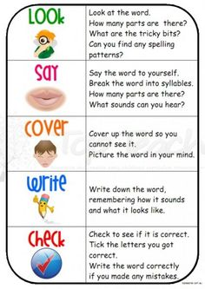
Challenge
If you are confident that you know all of the spellings on the list, can you find any other words that have the long /ay/ sound and place them in the right column on the chart? Good luck, and happy word hunting!
10 x table zapper
Name____________________________ Class___________
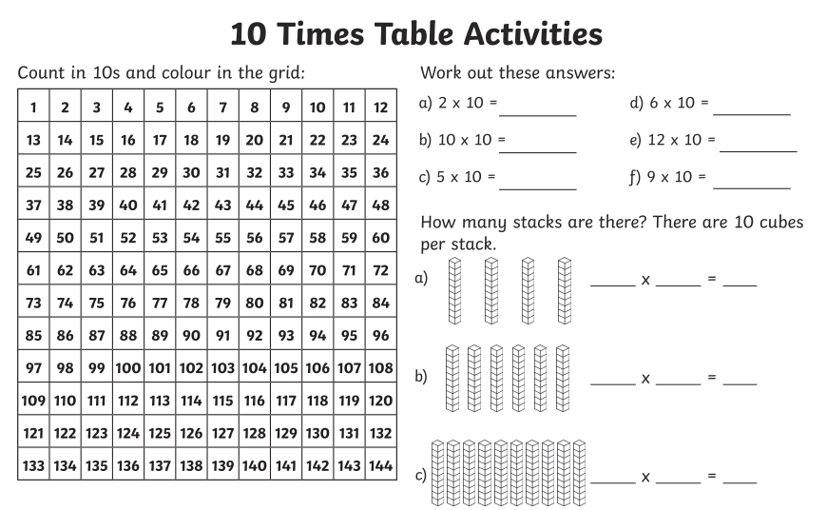
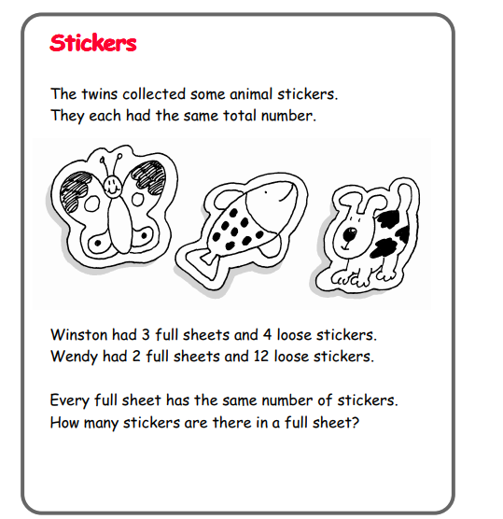
Fancy a challenge? Try this maths problem. Show your maths thinking!

Home Spellings
Use this space below to practise your spellings. Remember to look, say, cover, write, check. Can you do this four times for each word that you learn?
 | 1st Attempt | 2nd Attempt | 3rd Attempt | 4th Attempt
hole
lonely
rope
joking
woe
roast
shoal
know
zero
coal
toes
below

