Year 3 home-learning
Name:
Sent out: Monday 25th March
Home-learning due: Monday 15th April
Claim your 2 gems when you hand in your completed home learning!
Task | Notes | Tick off when completed, and return to your teacher by Monday 15th March. Get your gems!
Read 10 times to an adult over the two week period | Bring the signed bookmark to your teacher to be signed off and placed in the bookmarks raffle box.
Complete the 8 x table array challenge | Use the arrays to help you solve the multiplication and division facts.
Home spellings | For homework, children will be given the list of statutory Year 3/4 spellings. Some of these words are challenging and will need applying in sentences and discussed with an adult. Children need to be able to read and write these independently. We encourage children to choose and learn between four and ten words at home using the look, say, cover, write, check practice sheets. They will be tested in school by a friend at the end of the fortnight. They will tick off their correct spellings on a list in their classroom. Children are encouraged to be independent in managing this.  Please note that some children who are at a different stage of their spelling development, will be given alternative spellings to learn.
Complete any Maths No Problem practice worksheets that are sent home during this period | We will occasionally send home maths practice worksheets from our learning in school. These are a great way to reinforce the learning your child has done in class. Please encourage them to do as much as they can independently – or even better, to teach you how to do it!
Parent comment about your child’s home-learning success and challenges:

Please ask your child’s class teacher if you have any further question about these tasks.

Home Spellings
Over the next two-week period, you will be practising Year 3 spellings.
Use the attached lists to select and practise up to 10 spellings. A friend will test you in a few weeks to see if you can remember them!
1. | 2. | 3. | 4. | 5.
6. | 7. | 8. | 9. | 10.

Find out the meaning of each of these words. Can you use them in a sentence (spoken and written)?
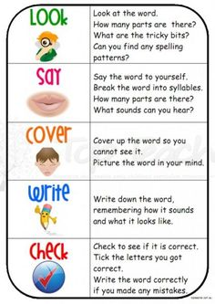

Spellings practise
Use this space below to practise your year 3 3 spellings. Remember to look, say, cover, write, check. Do this four times for each word that you learn.
Write your spellings in here | 1st Attempt | 2nd Attempt | 3rd Attempt | 4th Attempt
1.
2.
3.
4.
5.
6.
7.
8.
9.
10.

Use them in a sentence:
1._______________________________________________________________
2._______________________________________________________________
3. ______________________________________________________________
4. ______________________________________________________________

