Teaching and Learning Bulletin |  |  | March 2019  Volume 1, Issue 4
Hunter’s Bar Junior School
Your 2018-19 CPD Tool-kit now includes…  - Reducing students’ cognitive load in the class room.  - Using interleaved and spaced-out low stakes testing to strengthen pupils’ recall of knowledge.  - Planning and using Knowledge Organisers.  - Using live modelling in writing lessons to articulate success.  - Ways to deepen early graspers’ understanding in Maths.  - Comparing models to articulate success.  - Using the SEEC model to teach tier 2 vocabulary  Who to follow on Twitter: Tom Sherrington  @teacherhead  Tom is a well-respected, rather superb educational thinker and author who speaks a lot of sense to teachers and leaders about T and L.  Contents  1. Resource of the Week  2. SDIP priorities  3. Book study  4. TLC  5. Upcoming CPD  6. Staff voice | And we’re back in the room!  Take charge of improving your own practice!  Make use of this regular bulletin, filled with current and relevant information for all staff at Hunter’s Bar Junior School.
3. Other opportunities for your CPD - Book study
2. SDIP Priorities 2018-19
1. Resource of the Week
 | This half term, we will be using the TLC session to launch our next steps in shared writing approaches.  We will agree upon consistent approaches: teacher composition, joint composition and independent composition. We will also find ways to help our children model writing to their peers.  Here’s a great article by your friend and mine, Pie Corbett, to get you thinking:  https://www.teachprimary.com/learning_resources/view/master-shared-writing  Please carry out your peer observations for this cycle. Thanks.  Bamboo paper App  The Bamboo Paper app and mirroring software allows you to annotate children’s work ‘live’ on the IWB and to teach more flexibly around the classroom.  Please speak to James or Daniel Allen for moiré information. Your laptop will need ‘Lonely screen’ mirroring software installed.  4. TLCs | PDMs  Tues 26th February – TLC  Tues 5th March – Writing moderation  Tues 12th March – EPIC Curriculum theme reflection (flexible)  Wednesday 20th March - Vocabulary review of the  SEEC model  Tue 26th March - Parents’ Evening  5. Forthcoming Professional Learning  - Developing and embedding effective writing pedagogy  - Developing and embedding talk/vocabulary across the curriculum  - Implementing a Maths mastery curriculum through the MNP approach  - Wellbeing for pupils and staff | “The vocabulary CPD was a really engaging and informative session. I now give more consideration to which words I explicitly teach the children. The SEEC model has also equipped all of us with a consistent and structured approach to vocabulary teaching. The huge range of resources provided has also meant that we are now all equipped to make vocabulary learning more engaging and meaningful for the students.”  Cheers  Pete  Optional further reading of the book ‘Responsive teaching’. There are chapters on hinge questions and formative feedback that are well worth checking out.  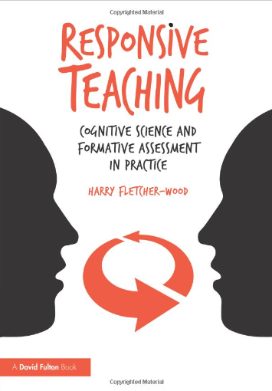  6. Staff voice on CPD –Pete Bainbridge
For further clarification on any of the points addressed in this bulletin, please see Alex.
If you would like to contribute to this T and L bulletin, please contact Alex.

