Y5 Home Learning
Out – Wednesday 21st November
Back in – Tuesday 27th November
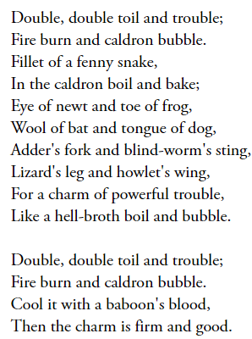
As part of our work on Shakespeare’s ‘Macbeth’, we would like you to create a perfect potion designed to make the ‘perfect teacher’, ‘perfect talk partner’ or the ‘perfect pet’. You need to use your imagination, expanded noun phrases and relative clauses. Even better if, like the Witches spell from Macbeth, it rhymes.

Feel free to be creative in the way you present your work!
My potion is to create the perfect _______________
______________________________________________________________________________________________________________________________________________________________________________________________________________________________________________________________________________________________________________________________________________________________
____________________________________________________________________________________________________
____________________________________________________________________________________________________

KIRF – Finding square numbers
Square numbers are made when you multiply the same number with itself:
3 x 3 = 9 9 is a square number.
5 x 5 = 25 25 is a square number.
We can also write them like this: 3² = 9 or 5² = 25
Using a systematic approach, find all the square numbers up to 12².
Finished? Can you find all the cube numbers upto 12³?
A cube number is a number times by itself, and then the answer is multiplied by the original number again.
e.g. 3 x 3 x 3 = 27 or 5 x 5 x 5 = 125
3³ = 27 or 5³ = 125

