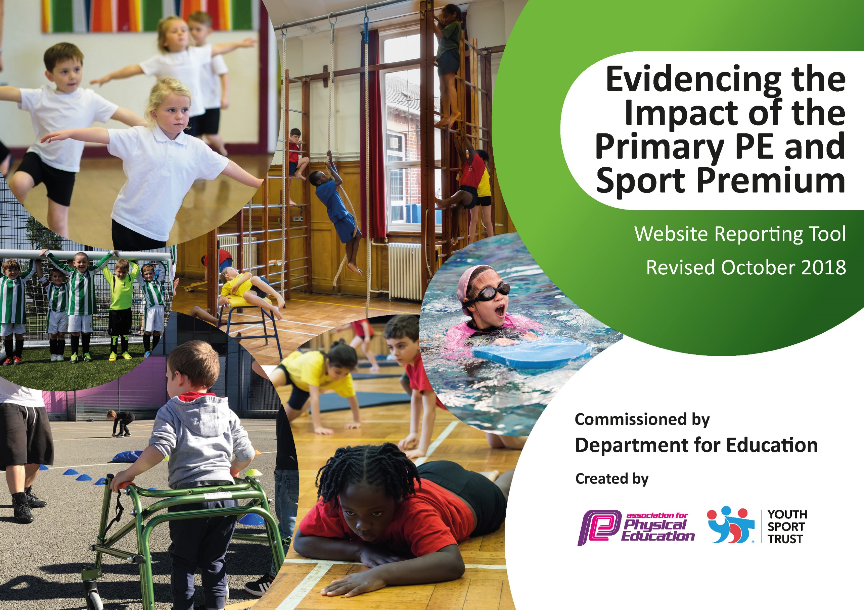
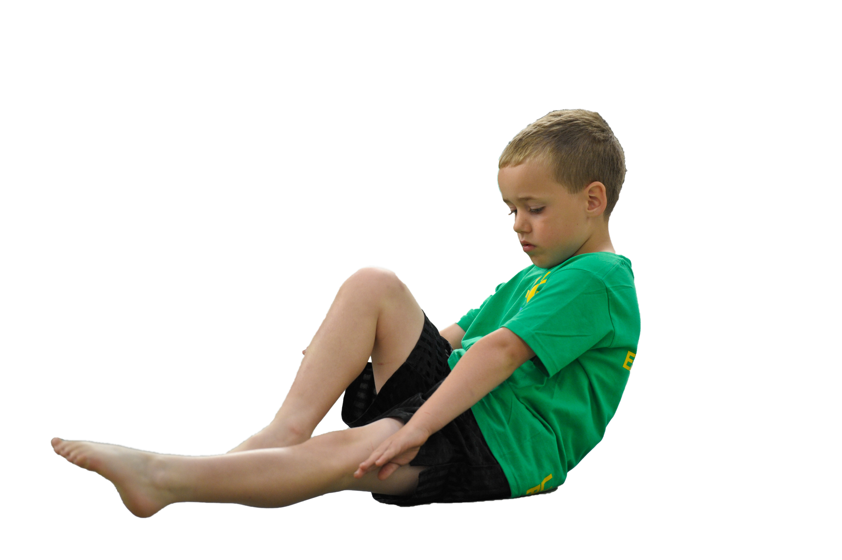
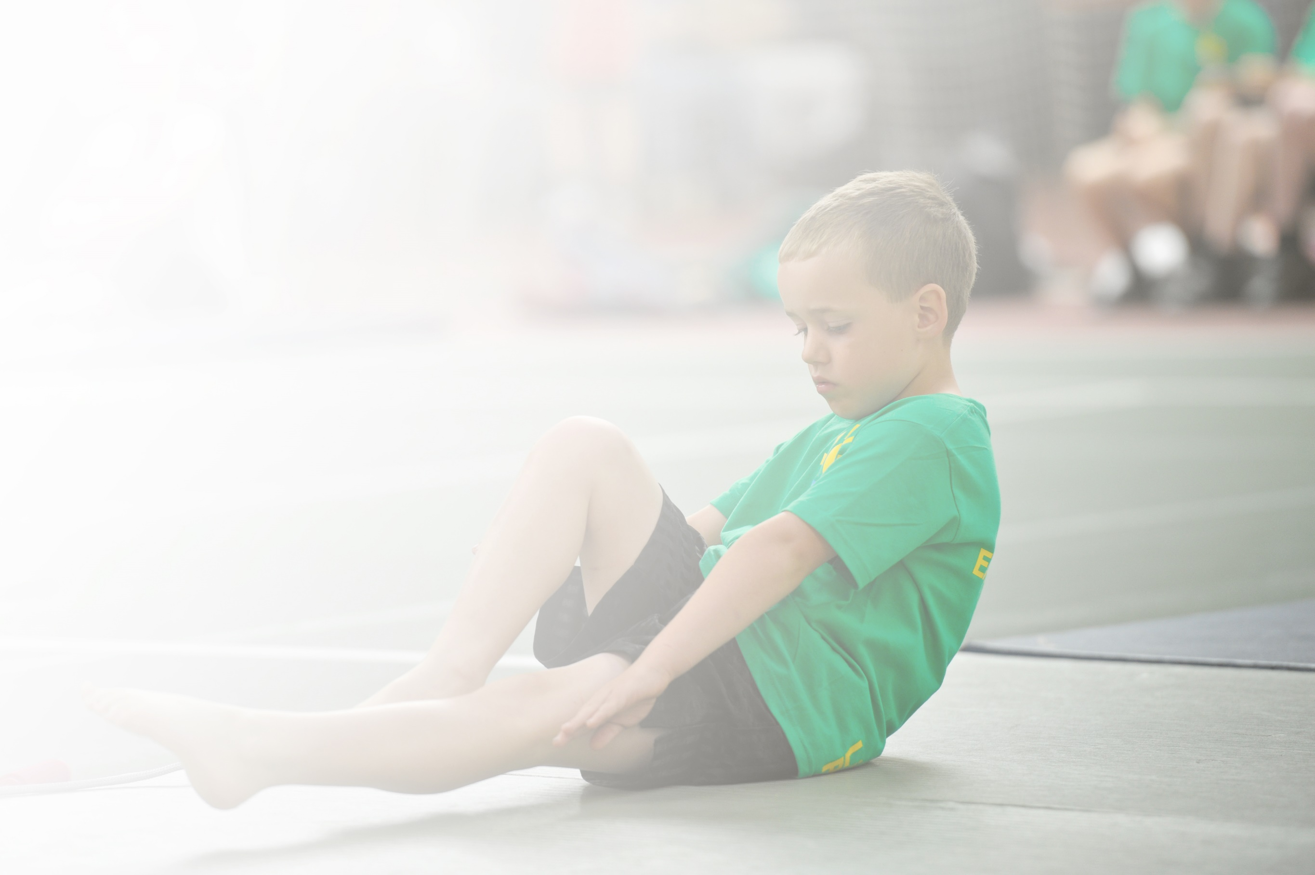
Schools must use the funding to make additional and sustainable improvements to the quality of Physical Education, Sport and Physical Activity (PESPA) they offer. This means that you should use the Primary PE and Sport Premium to:

- Develop or add to the PESPA activities that your school already offer
- Build capacity and capability within the school to ensure that improvements made now will benefit pupils joining the school in future years

Please visit gov.uk for the revised DfE guidance including the 5 key indicators across which schools should demonstrate an improvement. This document will help you to review your provision and to report
your spend. DfE encourages schools to use this template as an effective way of meeting the reporting requirements of the Primary PE and Sport Premium.

We recommend you start by reflecting on the impact of current provision and reviewing the previous
spend. Under the Ofsted Schools Inspection Framework, inspectors will assess how effectively leaders use the Primary PE and Sport Premium and measure its impact on outcomes for pupils, and how effectively governors hold them to account for this.

Schools are required to publish details of how they spend this funding as well as on the impact it has on pupils’ PE and sport participation and attainment by the end of the summer term or by 31 July 2019 at the
latest.
We recommend regularly updating the table and publishing it
on your website throughout the year, as evidence of your
ongoing review into how you are using the money to
secure maximum, sustainable impact. To see an
example of how to complete the table please
click HERE.

Support for review and reflection - considering the 5 key indicators from DfE, what development needs are a priority for your setting and your students now and why? Use the space below to reflect on previous spend, identify current need and priorities for the future.

Key achievements to date: | Areas for further improvement and baseline evidence of need:
- National recognition of engagement with competitive school sport, physical education and leadership opportunities through attainment of School Games Mark Bronze (2013-14), Silver (2014-15), Gold (2015-16) Gold (2016-17) Gold (2017-18).  - National recognition of commitment to school physical education and sport through attainment of Youth Sport Trust Silver Quality Mark (2017-19).  - Local recognition of best practice in physical education and sport through attainment of Yorkshire Sport Foundation Centre of Sporting Excellence accolade. (2016-17)  - Notable successes at Level 3 competitions include: Orienteering, Bouldering. | - Staff CPD for new Sports Leader to enable them to continue to drive the impact of PE and Sport in school.  - Support new class teachers with delivery pf PE od initial skills audit  - Identify most vulnerable children in school in terms of physical activity and ensure they have opportunities to take part in clubs, activities and competitions.

Meeting national curriculum requirements for swimming and water safety | Please complete all of the below:
What percentage of your current Year 6 cohort swim competently, confidently and proficiently over a distance of at least 25 metres?  N.B. Even though your children may swim in another year please report on their attainment on leaving  primary school. | 72%
What percentage of your current Year 6 cohort use a range of strokes effectively [for example, front crawl, backstroke and breaststroke]? | 72%
What percentage of your current Year 6 cohort perform safe self-rescue in different water-based situations? | 72%
Schools can choose to use the Primary PE and Sport Premium to provide additional provision for swimming but this must be for activity over and above the national curriculum requirements. Have you used it in this way? | No

Action Plan and Budget Tracking
Capture your intended annual spend against the 5 key indicators. Clarify the success criteria and evidence of impact that you intend to measure to evaluate for students today and for the future.

Academic Year: 2018/19 | Total fund allocated: £19,530 | Date Updated: June 2019
Key indicator 1: The engagement of all pupils in regular physical activity – Chief Medical Officer guidelines recommend that primary school children undertake at least 30 minutes of physical activity a day in school |  |  |  | Percentage of total allocation:
 |  |  |  | 30%
School focus with clarity on intended impact on pupils: | Actions to achieve: | Funding allocated: | Evidence and impact: | Sustainability and suggested next steps:
 | - Go Noodle challenge shared with each class to provide a vehicle for PA to happen in the classroom. Weekly competition in Gem assembly to reward those classes who have been most active.  - Active afternoon breaks – increase the number of resources available for staff to utilize. Build up a menu of PA options for CT’s to use. Email CT’s to highlight the statutory requirements to provide 30 minutes of PA each day and the positive benefits PA has on chn.  - Monitoring of club and activity data to identify least active cohort and develop intervention strategies to engage in regular physical activity  - Sensory Circuits Morning club  Organised before school club for identified children who have SEN. Circuits which have been specifically designed to meet their needs and enable them to have a more successful day.  - Skipping  Recruit two TA’s to lead organized skipping activities during morning break to encourage those least active to engage with fun and informal physical activity.  - Communicate National message  Regular key health messages shared with parents through; school website, twitter, sports newsletter  - Active lunchtimes supported by training and implementation of play leaders, active play equipment library |  | - Data collected weekly to identify number of minutes of PA completed on Go Noodle website. Impact to show an increased amount of daily PA in each class.  Impact – increased physical activity during class time. Improved attention and learning attitudes noted by teachers  - Teacher survey to collect snapshot of afternoon breaks and how they are utilized / delivered across the year groups. Conducted every half term.  Impact – not every class is consistently using active breaks as intended, for the majority who are, they report an increase in the childrens’ physical; activity compared to unstructured playtimes.  - Collect data of PA, club and competitive sport participation. Identify those who are least active. Focus group discussions / questionnaires to identify barriers to participation. Develop intervention strategies for taget chn.  Impact – success with clubs run by children – Jammy Dodgers with excellent take up from whole school and sustained membership.  - Collect data of those chn attending and look to target least active with other interventions.  Impact – class teachers and children self-reporting demonstrates a clear positive impact on identified children.  - Collect data with class Dojo to identify attendee’s  Impact – skipping activities are observed every day at playtimes and lunchtimes, though the take up is still largely girls.  - Increase awareness across school community as to the important role that physical activity has on health, wellbeing and attainment.  Impact – parental support for competitions has been strong, enabling events to go ahead.  - Data collected through Class Dojo to identify attendee’s.  Impact – change in morning break rota to class time on MUGA has resulted in greater participation, especially amongst girls.  In addition chn being active through structured play during lunchtimes has resulted in decrease in behaviour issues during lunch. | - Allocate a timetable slot when Go Noodle or PA is included as a daily routine.  - Active afternoon breaks to be non-negotiable for all class teachers. Equipment and resources to be built up to provide variety and maintain enthusiasm.  - Regular termly review meeting between PE lead and Headteacher to report data and identify those least active and focus group chn to monitor engagement.  - Identify other children (particularly new cohort for 2019/20) who would benefit from the club.  - Engage other staff members to support and expand the skipping programme. Encourage greater take up for boys.  - Include physical activity messages through coffee mornings already established. Continue regular health message updates through school communication messages i.e. twitter, facebook, website, newsletters  - Extend the range of activities available to children with resources to support.
Key indicator 2: The profile of PESSPA being raised across the school as a tool for whole school improvement |  |  |  | Percentage of total allocation:
 |  |  |  | 10%
School focus with clarity on intended impact on pupils: | Actions to achieve: | Funding allocated: | Evidence and impact: | Sustainability and suggested next steps:
 | - Active Maths project with DP. Create a series of active maths resources to use across whole school.  - Trial use of Personal Best model to encourage chn to try their hardest in every lesson that they take part in. Develop criteria to use to recognize chn who achieve their personal best. Set challenges in PE lessons and record data for chn to try to set and beat their own PB’s. Build into a rewards system |  | - All class teachers to engage with active maths project to increase physical activity in the classroom. Increase engagement with maths across all classes. Key maths skills reinforced.  Impact – each class engaged in active maths activities each half term as a minimum.  - Chn to demonstrate a desire to do their best with all lessons and tasks set. Have a greater understanding of target setting and putting strategies in place to achieve those goals. Demonstrate a perseverance and resilience to achieve and build upon each personal success.  Impact – in classes where this has been trailed; teachers report a good understanding from children as to the concept of personal best. Teacher’s report there has been many occasions where this has been relevant as a strategy to improve the quality of outcomes. | - More resources created to provide variety of activities and maintain engagement. Maths subject lead to specifically link active activities to maths scheme.  - Introduce model of Personal Best to all classes across school. Include as part of the whole school ethos / reward system to recognize each individual’s achievements and progress within a subject.

Key indicator 3: Increased confidence, knowledge and skills of all staff in teaching PE and sport |  |  |  | Percentage of total allocation:
 |  |  |  | 20%
School focus with clarity on intended  impact on pupils: | Actions to achieve: | Funding  allocated: | Evidence and impact: | Sustainability and suggested  next steps:
 | PE CPD programme for all CT’s. Initial audit conducted and personalized action plan to identify areas for development. Goal setting completed |  | Improved confidence and teaching of PE across whole school. Evidenced through observations, audit of strengths and areas for development. Individual teachers achieve their targets (set and agreed Nov 2018). Balance of teaching shift from (in some cases) 100% led by curriculum expert towards at least 50% delivery by class teacher. | Up until January 2019, new teachers to benefit from mentoring CPD programme. Existing teachers continue through transition of supported lessons towards independent PE lessons with periodic feedback and development opportunities.
Key indicator 4: Broader experience of a range of sports and activities offered to all pupils |  |  |  | Percentage of total allocation:
 |  |  |  | 20%
School focus with clarity on intended  impact on pupils: | Actions to achieve: | Funding  allocated: | Evidence and impact: | Sustainability and suggested  next steps:
Additional achievements: | - Range of lunchtime and after school clubs provided.  - Muga activities led by Teaching Assistants to provide range of school games activities |  | - Extra-curricular offer is extensive and attended by a variety of different target groups. Evidence is collected from monitoring Class Dojo and intervention groups  - MUGA activities are structured to provide maximum attendance by a range of target groups and compliments the extra-curricular offer and other lunchtime activities available. | - Continue to monitor success / uptake of extra-curricular offer and make necessary adjustments.  +  - Continue to deploy TAs to complement / enhance the provision of structured sporting activities and opportunities available to all groups of chn.
Key indicator 5: Increased participation in competitive sport |  |  |  | Percentage of total allocation:
 |  |  |  | 20%
School focus with clarity on intended  impact on pupils: | Actions to achieve: | Funding  allocated: | Evidence and impact: | Sustainability and suggested  next steps:
 | - Continue to enter SFSS and School Games competition events. Provide opportunities for more pupils to engage with competitive sport through entry and careful selection of targeted cohorts i.e. SEND, PP, least active.  - SSOC to be mobilsed to deliver ‘Gem’ competitions at level 1 |  | - Hours / events completed at level 1, 2 and 3 competitions.  Impact - chn from target groups involved in competitive sport through analysis of data collection – particularly involvement in Points Network games..  - SSOC leaders to be supported to plan, organize and deliver regular half termly ‘Gem’ competitions at level 1 | - Continue to provide competitive opportunities for all groups. Look to local partners to provide further opportunities for chn to compete.  - Engage Y5 pupils’ to prepare for taken responsibility during next academic year.

