Y5 Home Learning
Out – Wednesday 10th October
Back in - Tuesday 16th October
Complete the following decimal number bonds to 10 as quickly as you can. Record the time it took you here:___________
Knowing decimal number bonds to 10 is a key instant recall fact (KIRF) that is vital to accessing maths in Y5 and beyond. There are various strategies you can use to make some halves and doubles quicker and easier. Think carefully about what these may be and jot them down in the box below.
WAGOLL
6.3 + 3.7 = 10
4.5 + 5.5 = 10
8.1 + 1.9 = 10

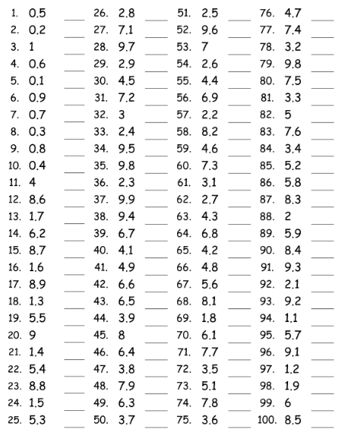
If there is a particular area of this quiz you have found challenging, then work on this to increase your knowledge in this area. Try reciting the number bonds in the car, doing them in your head as you brush your teeth, getting an adult to randomly fire questions at you out of the blue or any other way that you find helps.

Writing

Write the beginning of a narrative using ambitious vocabulary, expanded noun phrases and relative clauses, which create a sense of atmosphere and character.

________________________________________________________________________________________________________________________________________________________________________________________________________________________________________________________________________________________________________________________________________________________________________________________________________________________________________________________________________________________________________________________________________________________________________________________________________________________________________________
HELP A FRIEND - BONUS QUESTIONS
As we continue to delve deeper into our central idea This Is How We Survive, the children keep coming up with fantastic questions for us to explore. Here are two that we’d love children to investigate and see if they can help their friends with an answer.
Jacob asks: “Can you eat the snow in the Arctic in order to survive and get water?”
Dan asks: “What creates wind and makes it blow around?”

