Teaching and Learning Bulletin |  |  | June 2019  Volume 1, Issue 6
Hunter’s Bar Junior School
Podcast of the month  Mr. Barton’s Maths podcast – Craig. Barton interviews Mark McCourt on what is and what isn’t maths mastery. Controversial and entertaining! http://www.mrbartonmaths.com/blog/mark-mccourt-the-return-teaching-for-mastery/  Your 2018-19 CPD Tool-kit includes…  - Reducing students’ cognitive load in the class room.  - Using interleaved and spaced-out low stakes testing to strengthen pupils’ recall of knowledge.  - Planning and using Knowledge Organisers.  - Using live modelling in writing lessons to articulate success.  - Ways to deepen early graspers’ understanding in Maths.  - Comparing models to articulate success.  - Using the SEEC model to teach tier 2 vocabulary  Contents  1. Resource of the Week  2. SDIP priorities  3. Online read of the Week  4. News  5. Upcoming CPD  6. Recommended book | Take charge of improving your own practice!  Make use of this regular bulletin, filled with current and relevant information about CPD for all staff at Hunter’s Bar Junior School.  Thanks for completing the annual CPD survey! There is still time for those who needs to!
Read of the week

SDIP Priorities 2018-19
Resource of the Week
 | Mastering the art of apologizing  https://www.tes.com/magazine/article/teachers-and-students-must-master-art-apologising  Taking breaks is an important part of learning  https://digest.bps.org.uk/2019/05/20/taking-tiny-breaks-is-key-to-learning-new-skills/  What to do when you find a pupil unlikeable!  https://www.tes.com/news/what-do-when-you-find-pupil-unlikeable  Education news, opinion and research  ICT games- Look, cover, write check  Deceptively simple spelling game perfect for children practicing spellings from Y1 Phonics up to Y6 spelling patterns and rules. Get the laptops out first thing or in Spelling lessons…  http://www.ictgames.com/mobilePage/lcwc/index.html | Forthcoming Professional Learning  - Developing and embedding effective writing pedagogy  - Developing and embedding talk/vocabulary across the curriculum  - Implementing a Maths mastery curriculum through the MNP approach  - Wellbeing for pupils and staff  PDMs – Tuesdays  4th June – Maths journaling  11th June – TBC  12th June Twilight - Curriculum  18th June – Writing modelling  25th June Twilight – EPIC curriculum design  2nd July – Transition handover  9th July - Transition handover  16th July - Teaching and Learning celebration | 5* Recommended Read!  Rewarding students: should we? If so, how?  Harry Fletcher-Wood  https://improvingteaching.co.uk/2019/05/19/rewarding-students-should-we-if-so-how/  How To Explain Absolutely Anything to Absolutely Anyone: The art and science of teacher explanation – Andy Tharby  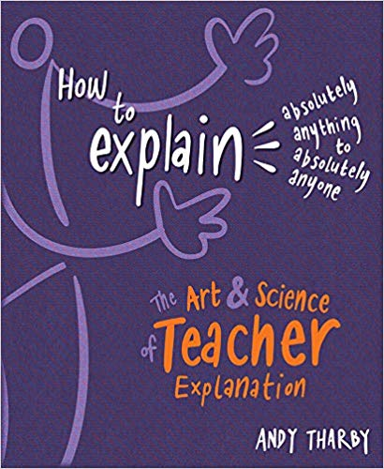  Andy Tharby talks teachers through a set of remarkably simple techniques that will help revolutionise the precision and clarity of their message.
For further clarification on any of the points addressed in this bulletin, or if you would like to contribute to this T and L bulletin, please contact Alex.
please see Alex.

