Subject | Task / activity | Easier / harder | Notes / resources
You are going to do a retelling of a short animation called Oktapodi - https://www.youtube.com/watch?v=badHUNl2HXU&safe=active (animation available here). There will be some build-up ideas and planning, followed by you retelling the animation as a narrative/a story from one of the character’s point of view.

All resources can be found below this planning on the webpage if the link on here doesn’t work.
Week 1  Writing – Day 1 | IMMERSION  First of all, watch the animation, more than once if you want/need to - https://www.youtube.com/watch?v=badHUNl2HXU&safe=active.  You then need to STORY MAP the animation from one of the character’s point of view (Oktapodi, the orange octopus, would be the easiest). Your story map should contain images with some annotations. | Easier – order these pictures from Oktapodi’s point of view and annotate them. (Pictures can also be found below on the web page if this link doesn’t work.)  Harder – choose the girl octopus or the driver, as there will be some gaps that you will need to fill in.
Writing – Day 2 | VOCABULARY WORK  Today you will be thinking about your chosen character’s emotions through the story and selecting some appropriate vocabulary to go with this.  Looking back at your story map from yesterday, draw a feelings bubble for each picture and use adjectives to describe how the character is feeling at that point. Try to come up with more than one emotion if possible and push yourself with the language you are using (a thesaurus would be a useful tool here if you have one). | Easier – use the word bank in the resources column to help you generate your emotions. | There is a basic word bank here – use these if you need to but see if you can improve them.
Writing – Day 3 | LANGUAGE BUILDING  Watch this video - https://www.youtube.com/watch?v=N4RthqSOcR0&safe=active  Today you will be generating some ‘show, don’t tell’ phrases that can help to make your writing more interesting and powerful. These phrases make your reader have to work a little bit to know how the character is feeling, which gives your reader a sense of achievement.  Using the sheet in the resources section (you’ll need to make it bigger!), select three of the emotions you generated yesterday and think of some phrases that would ‘show, not tell’ your reader how the character is feeling – e.g. sweat formed on his brow. (nervous) | Harder – if you have time left this week, create a ‘show, don’t tell’ poster which could be put up in class for the rest of the class to refer to. | 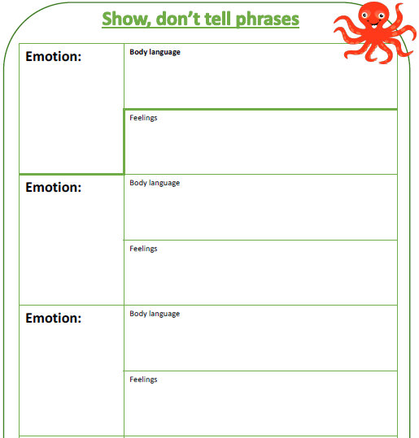
Week 2  Writing – Day 4 | PLAN  Today you need to start planning your retelling. Use the planning sheet in the resources section (again, you will need to make this bigger).  Make sure that you are referring back to your story map, as well as using the show, don’t tell phrases you have generated. |  | 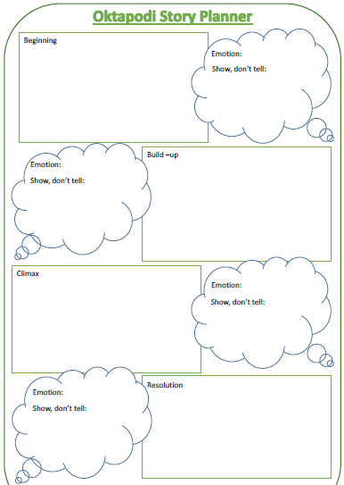
Writing – Day 5 | DRAFT  Time to draft your retelling today. Remember to use all the planning you have done: you have a story map, a plan, emotions work and some show, don’t tell, so use these as you draft. Don’t forget you are retelling the story from your chosen character’s point of view.  This may take you more than one day to complete: that is fine, you should have spare time. |  | Use all the resources you have worked on up to this point, especially your plan!
Writing – Day 6 | PROOFREAD, EDIT AND PUBLISH  Look back at your draft from yesterday. Time to edit and proofread it. Remember:  PROOFREADING – checking for and fixing errors (spelling, grammar, punctuation).  EDITING – improving where possible.  Then publish your retelling, on the template in the resources column (you will probably need more than one sheet). We will be asking for your published piece to be emailed in so we can see how you’ve done.

