Y5 Home Learning
Out – Wednesday 7th November
Back in – Tuesday 13th September
Complete the following random order multiplication grid as quickly as you can. Record the time it took you here:___________
Can you beat this next time we do a quiz like this?
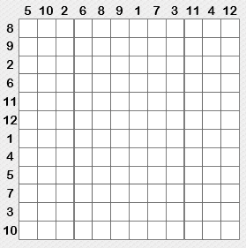
Knowing your multiplication tables and the inverse division facts is a key instant recall fact (KIRF) that is vital to accessing nearly all maths in Y5 and beyond.
If there is a particular area of this quiz you have found challenging, then work on this to increase your knowledge in this area. Try reciting the tables in the car, doing them in your head as you brush your teeth, getting an adult to randomly fire questions at you out of the blue or any other way that you find helps.
Writing
Write a paragraph describing this image. Use relative clauses and modal verbs.

What a Good One Looks Like (WAGOLL)
He shouldn’t have been there. He was lost in the wilderness, which seemed never ending, and needed to get back to his owner. His heart was racing and he walked as fast as he could, which was surprising quickly, in the direction he felt like his home was to be found.
________________________________________________________________________________________________________________________________________________________________________________________________________________________________________________________________________________________________________________________________________________________________________________________________________________________________________________________________________________________________

