HBJS CPD Bulletin |  |  | January 2020  Volume 2, Issue 2
Hunter’s Bar Junior School, Sheffield.
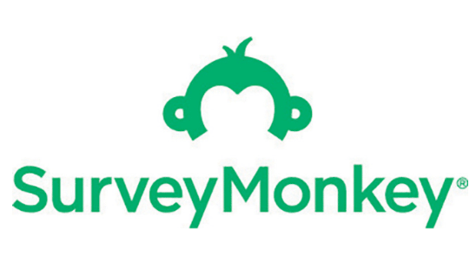  Thank you for continuing to evaluate the impact of our weekly CPD.  It helps to ensure that professional learning is always improving at HBJS.  Who to follow on Twitter: David Didau  - Learning Spy – Brain food for the thinking teacher  Contents  1. Edu book to check out  2. SDIP priorities  3. Podcast of the month  4. What’s Tommy 2 Tips got say for himself?  5. Upcoming PDMs  6. What are we working on? | Happy New year and welcome back to school!  Take charge of improving your own practice!  Make use of this regular bulletin, filled with current and relevant information for all staff at Hunter’s Bar Junior School.
3. Podcast of the month
2. SDIP Priorities 2019-20
1. Edu - book to check out
 | 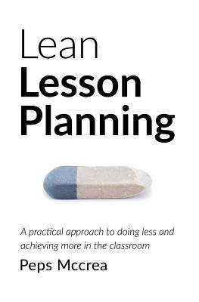  - Want to make your planning more efficient and impactful? Look no further!  4. Tommy 2 Tips gives his insights from research.  Tip 1: Tell the learners that they will be expected to teach their partner later on in the lesson. If so, they will be more likely recall the learning later on.  (Nestojko et al, 2014)  Tip 2: Reading out aloud. Get kids to read material out aloud to themselves whilst learning something new. This takes advantage of the production effect and can help with recall. (Forrin and McCloud, 2018).  We all look forward to hearing more form Tommy next time. | - Well being  - Vulnerable learners  - AFL and Summative  assessment  - Developing the school  curriculum  - Oracy and vocabulary  - Reading fluency  5. Forthcoming PDMS - Wednesdays  Week 1 Coding at HBJS – Chi Dire presents RODOCODO! Whole school coding  Week 2 Retrieval practice review  Week 3 Launching  P4C with Paul Stockley  Week 4 TLC#4  Week 5 No PDM (TLC feedback time)  Week 6 Oracy review | - The Learning scientists talk all things Retrieval practice.  6. What are we working on at the moment?  Embedding theme concepts  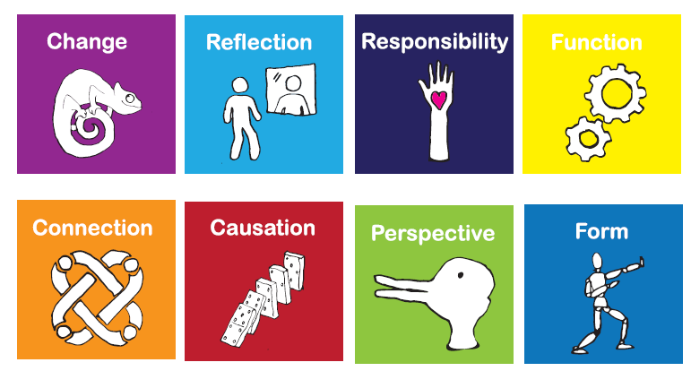  Integrating Oracy and the vocab SEEC model into planning and learning across the curriculum.  Developing learners’ reading fluency  Embedding ‘Boxed in Success Criteria’ in our writing planning. Future PDM coming in Summer 1.  Retrieving key knowledge through daily, weekly and monthly recalll.  Eliciting evidence from learners and acting upon it.
For further clarification on any of the points addressed in this bulletin, please see Alex.
If you would like to contribute to this T and L bulletin, please do pipe up.

