Teaching and Learning Bulletin |  |  | April 2019  Volume 1, Issue 5
Hunter’s Bar Junior School
Podcast of the month – The Learning Scientists podcast http://www.learningscientists.org/podcast-episodes/  Fantastic podcast covering retrieval practice, spaced learning and other aspects of evidence based learning.  Your 2018-19 CPD Tool-kit includes…  - Reducing students’ cognitive load in the class room.  - Using interleaved and spaced-out low stakes testing to strengthen pupils’ recall of knowledge.  - Planning and using Knowledge Organisers.  - Using live modelling in writing lessons to articulate success.  - Ways to deepen early graspers’ understanding in Maths.  - Comparing models to articulate success.  - Using the SEEC model to teach tier 2 vocabulary  Contents  1. Resource of the Week  2. SDIP priorities  3. Book study  4. TLC  5. Upcoming CPD  6. Free CPD | Take charge of improving your own practice!  Make use of this regular bulletin, filled with current and relevant information about CPD for all staff at Hunter’s Bar Junior School.
3. Other opportunities for your CPD - Book study
2. SDIP Priorities 2018-19
1. Resource of the Week – The Secret door
 | 4. Summer 1 TLC focus  Looking for some quick off-the- bat visual stimuli to inspire a potentially dull grammar starter? Well look no further than The secret door. Simply click on the door and it will take you to infinite curious locations around the world that you can explore using google street view. http://ww3.safestyle-windows.co.uk/the-secret-door/  Interrupting the forgetting  This half term, we will be using the TLC session to review how we can use retrieval practice as part of our daily and weekly practice to help strengthen storage strength and improve recall of past learning.  We will briefly look at the evidence base, share our current practice and consider the most effective ways to use it with our pupils.  Here’s a great article from a Y6 teacher about the impact of RP in their classroom.  https://www.tes.com/news/retrieval-practice-how-it-helped-me-improve-sats-results  Please carry out your peer observations for this cycle. Thanks. | 5. Forthcoming Professional Learning  - Developing and embedding effective writing pedagogy  - Developing and embedding talk/vocabulary across the curriculum  - Implementing a Maths mastery curriculum through the MNP approach  - Wellbeing for pupils and staff  PDMs  17th April- Year team theme reflection time (to use flexibly)  24th April - CPOMS / Safeguarding  1st May – TLC on retrieval practice  8th May – Assessment  15th May – Subject leadership time  22nd May - Wellbeing | 6. Free CPD reads and listens  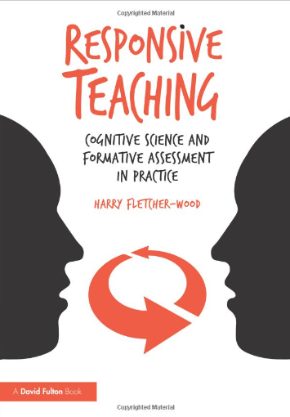Don’t forget, there is optional further reading of the book ‘Responsive teaching ‘to help your personal CPD. Check out the chapters on hinge questions and formative feedback. https://improvingteaching.co.uk/author/hazzer2001/  - What is dual coding?  https://www.teachertoolkit.co.uk/2019/04/08/dual-coding/  - David Didau on his latest book, ‘Making kids cleverer’.  http://www.mrbartonmaths.com/blog/david-didau-making-kids-cleverer/  - Rosenshine’s ‘Principles of instruction’ – The core of evidence-based teaching.  https://teacherhead.com/2018/06/10/exploring-barak-rosenshines-seminal-principles-of-instruction-why-it-is-the-must-read-for-all-teachers/
For further clarification on any of the points addressed in this bulletin, or if you would like to contribute to this T and L bulletin, please contact Alex.
please see Alex.

