Y5 Home Learning
Out – Wednesday 3rd October
Back in - Tuesday 9th October
Complete the following doubling and halving problems as quickly as you can. Record the time it took you here:___________
Knowing halves and doubles of 2 digit numbers is a key instant recall fact (KIRF) that is vital to accessing maths in Y5 and beyond. There are various strategies you can use to make some halves and doubles quicker and easier. Think carefully about what these may be and jot them down in the box below.
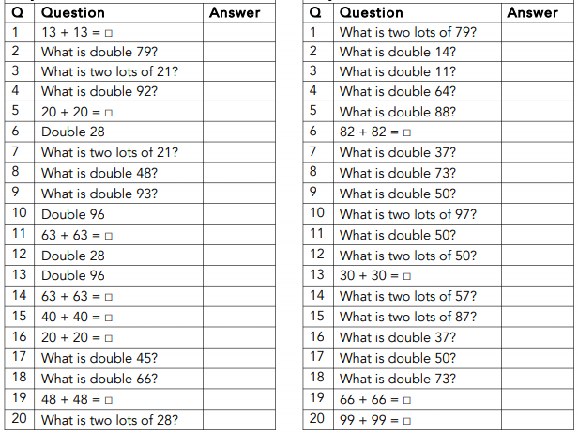
WAGOLL
63 + 63 = 60 + 60 + double 3 = 126

Writing

Write the beginning of a narrative using ambitious vocabulary and a sprinkling of speech to show character and move the plot forward. Use the starter given, or one of your own.

What a Good One Looks Like (WAGOLL)

Slowly, a foot moved, then the trunk, then a loud growl shook the cavern. The scientist, who was paralysed by fear, could not believe the sight before her eyes.
‘Come quickly, Jen, we don’t have much time!” yelled Adam. Jen stood wide-eyed, with a look of sheer horror imprinted on her face.
“Come on, now, before it’s too late!” pleaded May.
The ice began to slowly crack, breaking off into sections, releasing rivers of gushing water and sending dangerous shards of ice in all directions.

________________________________________________________________________________________________________________________________________________________________________________________________________________________________________________________________________________________________________________________________________________________________________________________________________________________________________________________________________________________________________________________________________________________________________________________________

