A year 4 writer’s toolkit

- Build each sentence with care

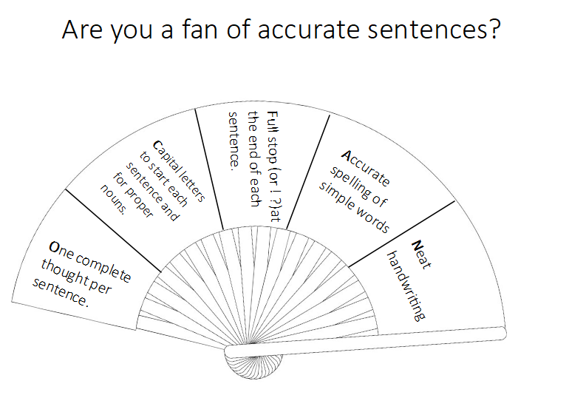

Each sentence should be about one complete thought and should have a start, middle and end.
I love playing football with my friends. CORRECT.
I love playing football with my friends it is so much fun. This is WRONG. There are two thoughts in one sentence. It needs splitting up into two sentnces.

Capital letters to start each sentence and for proper nouns.

Hunter’s Bar
West Ham United
Mr. Bainbridge
sheffield is spelled wrong.

Full stops used to end a sentence (or !?)

Accurately spell simple words accurately (there, because, were etc.)

Neat handwriting that is joined and sits on the line.

Wow!
Do you agree?
Lists with commas. Rod, Jane, Bungle and Freddy left the room.
No missing words

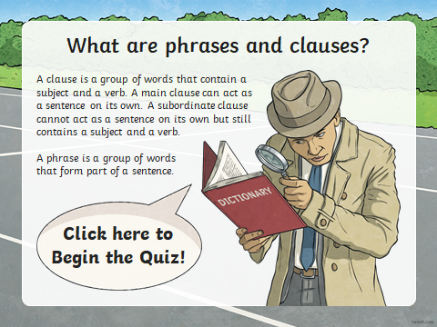
Know the difference between a phrase and a clause.

- Obey the rules of grammar

Choose nouns or pronouns to avoid repetition. (He, she, they, him, her, them)

Write, explain and find these word types: noun, verb, adjective, adverb, subject, object, determiner and pronoun.

Using the present perfect form of verbs instead of past tense e.g. ‘She has lost her stickers’ and ‘I have lived in Sheffield for a long time.’

- Write brilliant stories

Start a new paragraph when you change the time, person, topic or place. (TiP ToP)

Describe a setting in detail e.g. a rainforest, school or tundra

Describe a character with adjectives, powerful verbs and show don’t tell techniques.
As the footsteps tapped closer and closer, Jack felt his stomach muscles tighten. He flattened himself to the wall, the gritty bricks against his cheek. Sweat chilled his palms. He used both hands to steady the gun.

Write a story following a plot or storyline.

- Extend your sentences

Join main and subordinating clauses by using conjunctions, (including when, if, because, although etc)

Use direct speech accurately. “I’m late for school!” screamed Mr. Beauchamp.

Show time, place and cause using conjunctions (when, before, while, after/where, wherever/ so that, because)

Use fronted adverbials at the start of a sentence, followed by a comma
e.g. Silently and slowly, the man put his newspaper down.

- Use spelling patterns

Use the possessive apostrophe with all singular nouns
e.g. The teacher’s green pen.

Use prefixes (in-, im-, sub- ,inter- and suffixes (-tion, -sion, -ssion

International, submerge, station, dimension, possession

Use the first 2 or 3 letters of a word to check its spelling in a dictionary

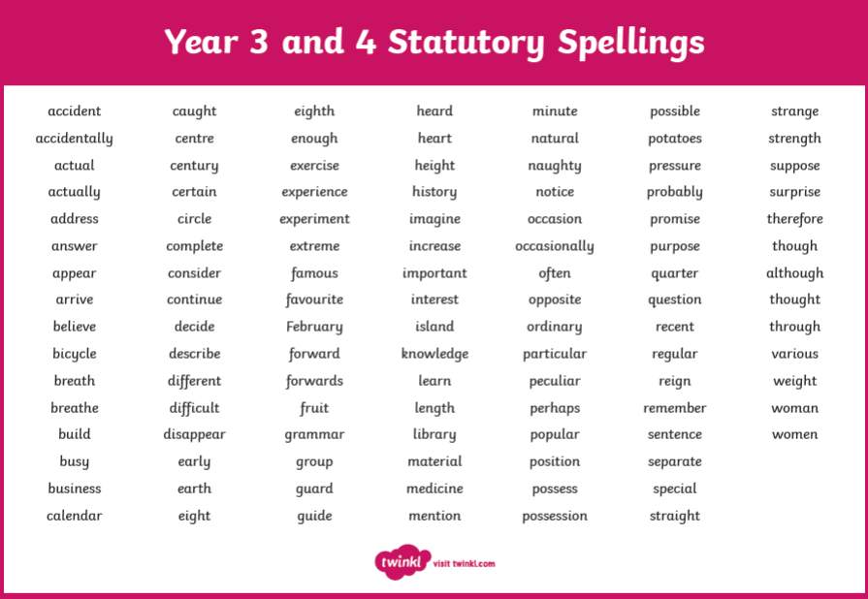
Learn and use the Year 3/4 spelling list:

