Teaching and Learning Bulletin |  |  | November 2018  Volume 1, Issue 2
Hunter’s Bar Junior School
Knowledge Organisers  How will we use our KOs to support a knowledge rich classroom? Low stakes testing, anchoring…?  Word to the wise  We will continue to sharpen our evaluative skills in the classroom. What impact are our CPD threads having on targeted children? How do LA children react when we give them concrete resources to explore with in Maths? What impact is the ‘In focus’ task having on our PP children?  Who to follow on Twitter: @ICT_MrP Lee Parkinson provides engaging ways to use technology to help raise standards in English across the curriculum. His teacher videos are very funny, too!  Contents  1. Resource of the Week  2. SDIP priorities  3. Current Focus in the Classroom  4. Book study  5. Upcoming CPD  6. Podcast of the month | Take charge of improving your own practice!  Make use of this regular bulletin, filled with current and relevant information for all staff at Hunter’s Bar Junior School.
3. Current Focus in the Classroom
2. SDIP Priorities 2018-19
1. Resource of the Week
 | www.readinga-z.com  This reading website has more than 2,500 downloadable books with accompanying lesson plans and resources. 14 day trials are available.  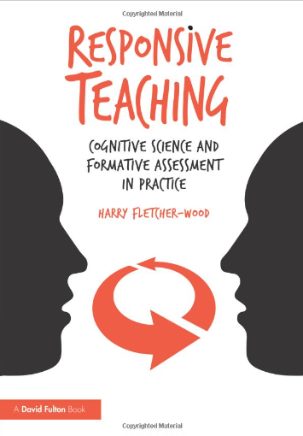  We will be reading chapter 3 of the book and thinking about how we can show pupils what success looks like in a lesson. Themes covered include metacognition, and modelling. Check out the evidence-rich techniques to try out!  4. Book study | 6.11.18 TLC – Application of cognitive load theory in the classroom  13.11.18 Year group meeting.  19.11.18 Twilight–Kelly Ashley writing CPD – working towards independence in writing  20.11.18 PDM - Writing action planning / Effective use of TAs  27.11.18 - EPIC curriculum training  4.11.18 – No PDM due to Parents’ evening.  11.12.18 Curriculum reflection (year teams and phase)  18.12.18 Maths review of reasoning and journaling. Where do we go now?  5. Forthcoming Professional Learning (so far..)  - Developing and embedding effective writing pedagogy  - Developing and embedding talk/vocabulary across the curriculum  - Implementing a Maths mastery curriculum through the MNP approach  - Wellbeing for all | 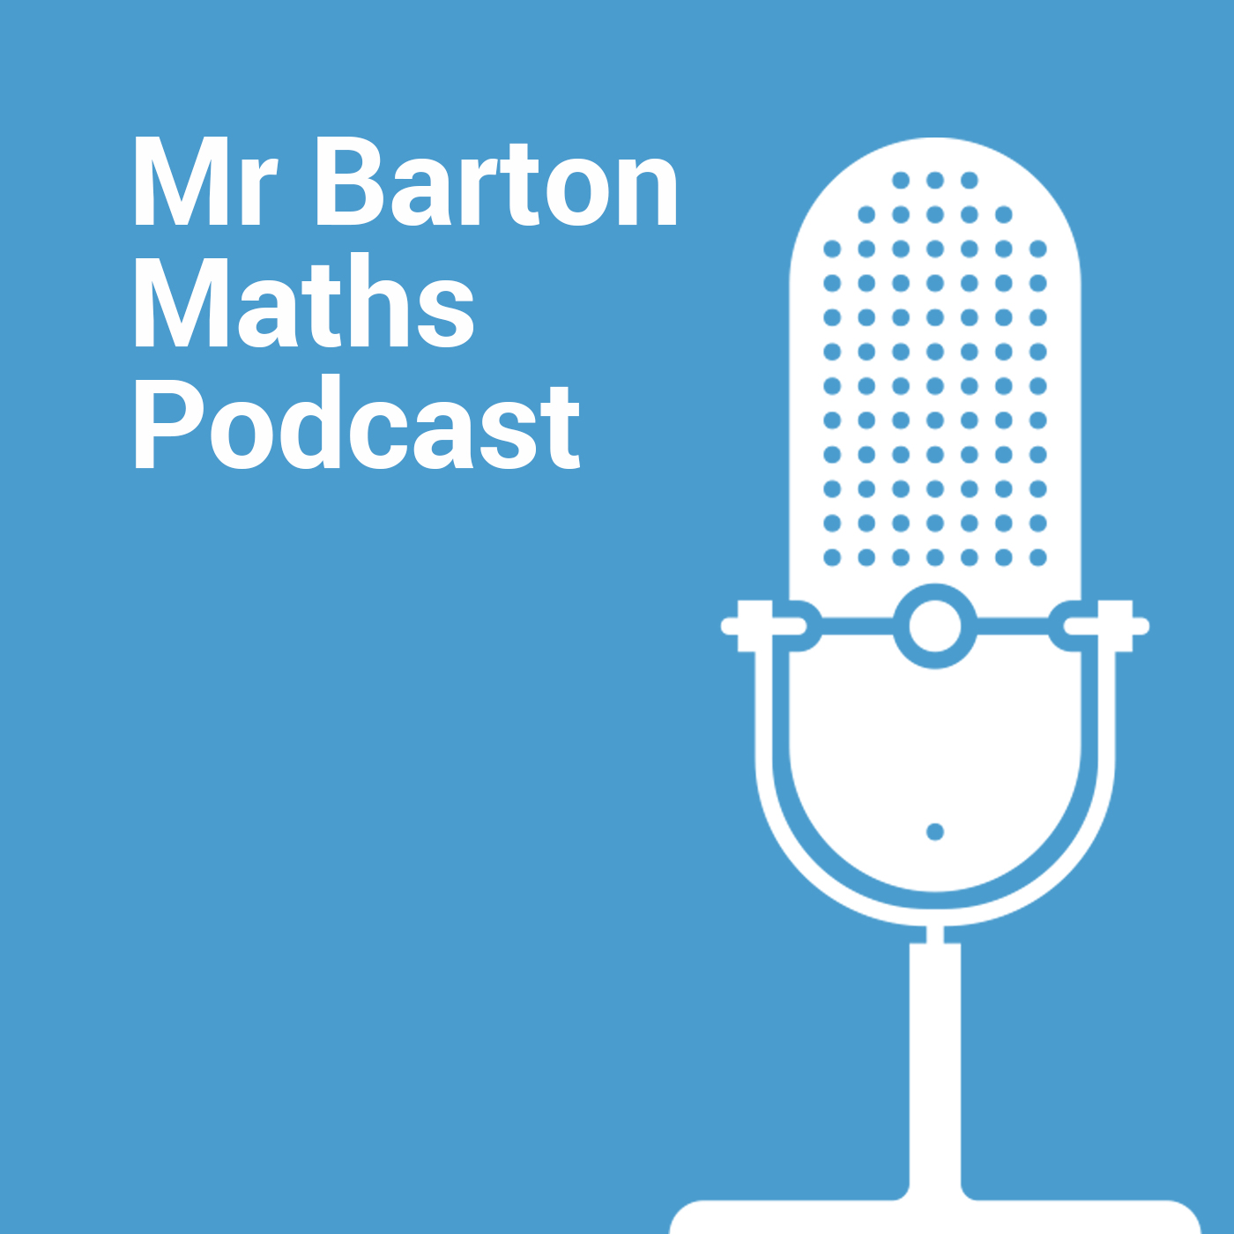  “On the Mr Barton Maths Podcast I interview guests from the world of education who interest and inspire me. They may be fellow teachers, bloggers, thinkers, or people of influence. As well as discussing my guest's particular areas of interest, I always like to dig deep into their lesson planning process, and ask them to describe lessons that did not go so well and what they learned from the experience.”  Reducing cognitive load in the classroom  This half term we will be reducing cognitive load in our lessons and adding germane load to support our pupils receiving streamlined learning that doesn’t over load their working memories.  6. Podcast of the month
For further clarification on any of the points addressed in this bulletin, please see Alex or Michael
If you would like to contribute to this T and L bulletin, please contact Alex.

