Are you interested in becoming a play leader?

Would you be prepared to?

- Give up some of your lunchtimes.
- Help to organise games & activities for children in the playground & in the Infant School.
- Be responsible for handing out & collecting in play equipment.
- Help to make your playground a safe & happy place to play.
- Complete a playground leader training course.

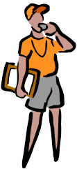
Please see your class teacher for more details and an application form.

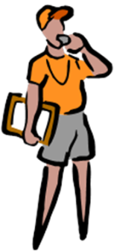
Y5/6 Play Leaders
Application Form

Name: ___________________________________________________ Class: J_________
Complete the sentence giving reasons why you would like to be a play leader.
I want to be a play leader because_________________________________________________
__________________________________________________________________________________
__________________________________________________________________________________
__________________________________________________________________________________
__________________________________________________________________________________
Choose 5 words that you think describe a good playground leader.

Please provide an external reference:
You need to get someone who knows you well to complete the section below. This could be a family member, a friend, someone who coaches you, an adult in school – anyone who would recommend you as a Sports Leader. I confirm that _____________________ would make a good Sports Leader
because ___________________________________________________________________________
__________________________________________________________________________________
__________________________________________________________________________________
__________________________________________________________________________________
__________________________________________________________________________________
__________________________________________________________________________________
Signed:
How do you know the applicant?

The Game - Please describe a game that you could organise for children to play during their free time at school. Read all of the questions before you start writing to make sure your game is suitable.
Describe the game: __________________________________________________________________
__________________________________________________________________________________
__________________________________________________________________________________
__________________________________________________________________________________
__________________________________________________________________________________
How many children can play? ____________
Will you need any equipment? If so, what? Will there be time to get this out, set up, and put away in a play time or lunch time? __________________________________________________________________________________
__________________________________________________________________________________
__________________________________________________________________________________
__________________________________________________________________________________
How much space will you need? Think about the rest of the school who aren’t playing your game.
__________________________________________________________________________________
__________________________________________________________________________________
__________________________________________________________________________________
__________________________________________________________________________________
Where will it be safe to play? __________________________________________________________
__________________________________________________________________________________
__________________________________________________________________________________
__________________________________________________________________________________
__________________________________________________________________________________
How could you make the game easier or harder so that everyone is challenged?
__________________________________________________________________________________
__________________________________________________________________________________
__________________________________________________________________________________
__________________________________________________________________________________

