Teaching and Learning Bulletin |  |  | November 2019  Volume 2, Issue 1
Hunter’s Bar Junior School, Sheffield.
Who to follow on Twitter: @87History  Research and Resources for every classroom by Kate Jones.  Loads of useful resources to support retrieval, dual coding and history.  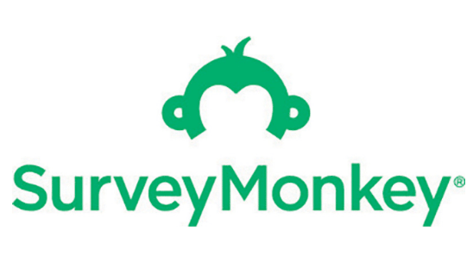  Thank you for continuing to evaluate the impact of our weekly CPD.  It helps to ensure that professional learning is always improving at HBJS.  Contents  1. *Clickable resources of the Week  2. SDIP priorities  3. Podcast of the month  4. Follow the bright spots  5. Upcoming CPD  6. What are we working on? | Welcome back to the new and improved *clickable  T and L Bulletin.  Take charge of improving your own practice!  Make use of this regular bulletin, filled with current and relevant information for all staff at Hunter’s Bar Junior School.
3. Podcast of the month
2. SDIP Priorities 2019-20
1. Clickable resources of the Month
 | 4. Follow the bright spots  *Beware of the Matthew Effect – Marc Rowland helps us think in different way about disadvantaged children.  * A smart overview of memory and how we learn, narrated by Jonathon Hutchinson.  * David Didau has hooked up with BBC Bite size to create these three animated videos about learning. They are well worth a look.  - The Tower Hamlet talk frames (In the Oracy folder)  - * The noun project images gallery  - * The ‘Boxed in’ success criteria model | 5. Forthcoming Tuesday PDMS at HBJS  Week 1 – No PDM (Lyfta CPD payback).  Week 2 - Comparative judgement in writing, hosted by Jack and Daniel.  Week 3 - Reading fluency, hosted by Nea and Jackie.  Week 4 - TLC 3 - Check, reflect, respond - Eliciting evidence from pupils and acting on it, hosted by myself plus a welcomed host for Y5/6 (any takers?)  Week 5 – No PDM due to Parents’ evening.  Week 6 - Spelling – an agreed and simplified approach, hosted by Mr.Jack Goodhand.  Week 7 - No PDM (TLC feedback payback)  - Well being  - Vulnerable learners  - AFL and Summative  assessment  - Developing the school  curriculum  - Oracy and vocabulary  - Reading fluency | 6. What are we working on at the moment?  Integrating Oracy into planning and learning across the curriculum.  Evaluating our weekly CPD experiences to support continuous improvement.  Trialing ‘boxed in Success Criteria’ in our writing planning.  *Using Silent Teacher as a way to help our pupils elicit and articulate success.  Embedding theme concepts into the unit themes.  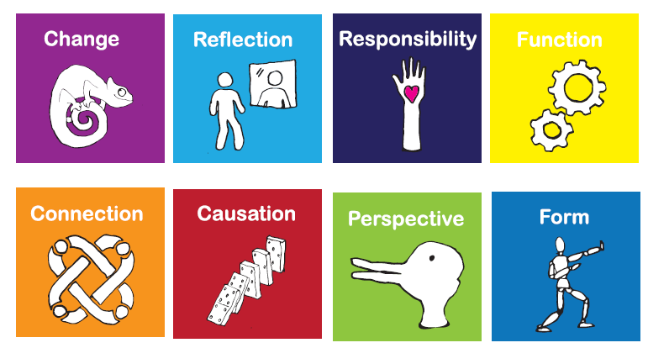  Retrieving key knowledge through quizzing and memory tasks.  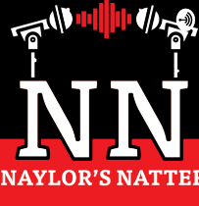*  Listen to Pupil premium champion Marc Rowland (soon to be best friend of HBJS) talk on Naylor’s Natter podcast about how to support disadvantaged learners.
For further clarification on any of the points addressed in this bulletin, please see Alex.
If you would like to contribute to this T and L bulletin, please do pipe up.

