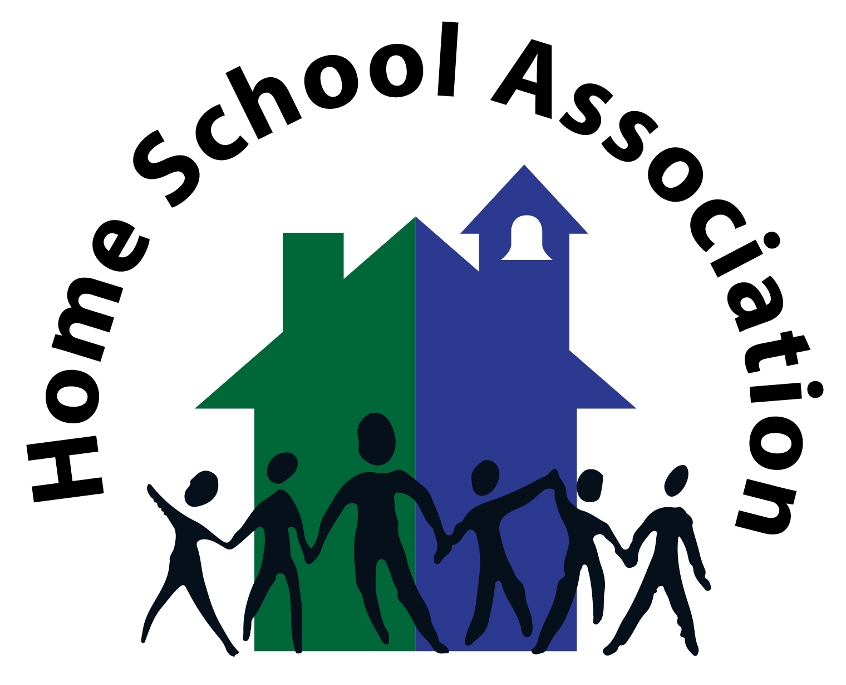
HBJ HSA: 100+ Club

As your child is a pupil of Hunter’s Bar Junior School, you automatically become members of the HSA and you are warmly welcomed to participate in many different ways.
We would like to introduce you to (or remind you of) our 100+ Club, an excellent way of winning some great cash prizes whilst directly assisting your child through the provision of items and facilities in school.
How it works:
Membership of the 100+ Club is just £12.00 per year, per number and you can have as many numbers as you like. A draw of all membership numbers will be held on the 1st of every month or the first school day afterwards (two draws will take place in July to cover August and two draws will take place in October to cover September). If you have an existing number you can keep this by re-joining. New members will be randomly allocated numbers. You can join at any time in the year and simply pay for the number of months remaining (this will be automatically updated on ParentPay).
We will pay out half our takings in a cash prize (far better odds than the lottery) and the other half will be spent on school projects, chosen by the Student Council.
What do you need to do now?
To become a member, or renew your membership, please complete the form below and send it to the school reception for the attention of the HSA. Payment can be made by cash (to be included with the application form) or via Parent Pay. Please feel free to tell your friends and relatives about this exciting new initiative and get them involved. All over 16 are welcome to join.
Deadline for membership applications for the first double draw is Friday 29th September.
So what are you waiting for? Join now and be included in the first draw of the year, on Tuesday 3rd October 2017. The draw will then be held on the first day of each month thereafter.
Thank you for your continued support and good luck! The HSA

Hunter’s Bar Junior School HSA
100+ Club
Details of Member
Title……………… Forename(s)………………………………………………….…..
Surname…………………………………………………………………………………
Tel……………………………………….. email……………………………………….
Child’s name………………………………………………….. Class:……………….
-----------------------------------------------------------------------------------------------------------
I would like to purchase…………. Membership (s)
I enclose the sum of £…....

I have purchased …….Membership(s)
I have paid on Parent Pay
(Please delete as necessary)

Signature……………………………………………………………………………………

Please contact the school office if you require more copies of this form for friends and family.

