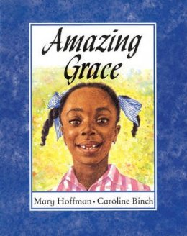
Amazing Grace

By Mary Hoffman

Illustrated by Caroline

Binch

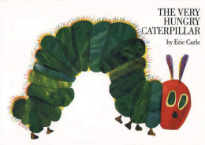

The Very Hungry Caterpillar

By Eric Carle

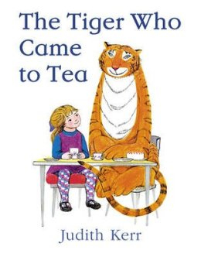
The Tiger Who Came to Tea
By Judith Kerr

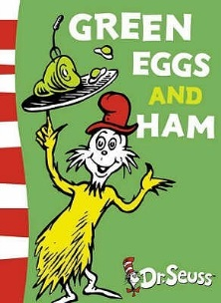
Green Eggs and Ham

By Dr. Seuss

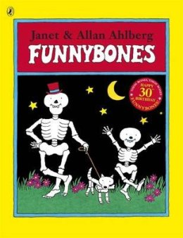
Funny Bones

By Allan Ahlberg

Illustrated by Janet Ahlberg

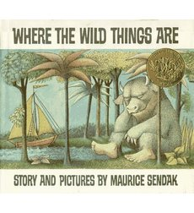
Where the Wild Things Are
By Maurice Sendak

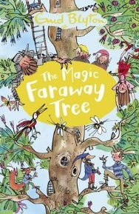
The Magic Faraway Tree

By Enid Blyton
(Then try ‘The Wishing Chair)

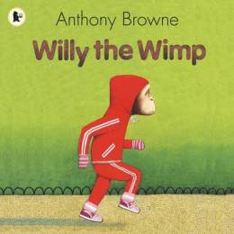
Willy the Wimp
By Anthony Browne
(Then try ‘Gorilla and the Tunnel’)

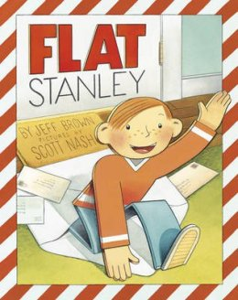
Flat Stanley

By Jeff Brown

Illustrated by Scott Nash

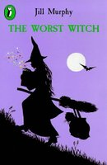
The Worst Witch

By Jill murphy

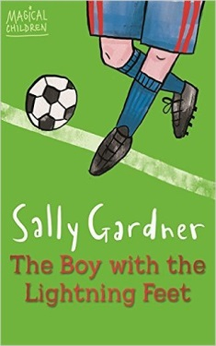

The Boy with the Lightning Feet

By Sally Gardner
(Then try ‘’Maggot Moon’)

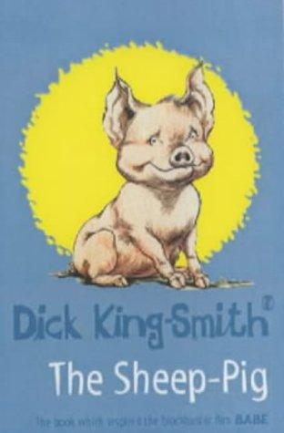
The Sheep Pig
By Dick King-Smith

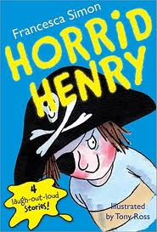

Horrid Henry Series

By Francesca Simon

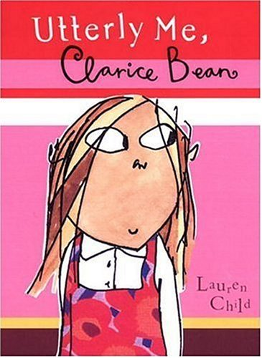
Clarice Bean Series

By Leon Child

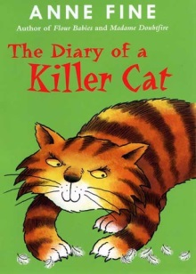
Diary of a Killer Cat
By Anne Fine

(Then try ‘’The Chicken Gave it to Me’)

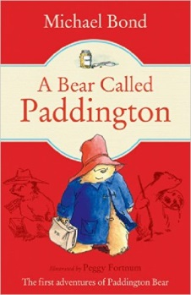
A Bear Called Paddington

By Michael Bond

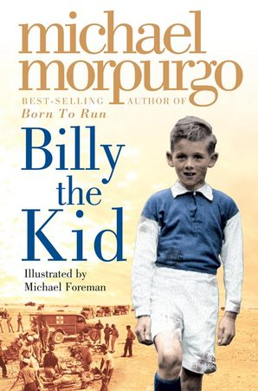
Billy the Kid
By Michael Morpurgo
(Then try ‘Cool’ or ‘Shadow’)

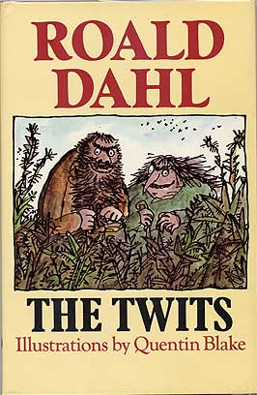
The Twits

By Roald Dahl

Illustrated by Quentin Blake

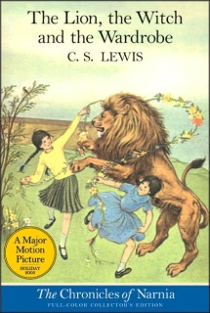
The Lion, The Witch and The Wardrobe

By C.S. Lewis
(Then try all the other Chronicles of Narnia)
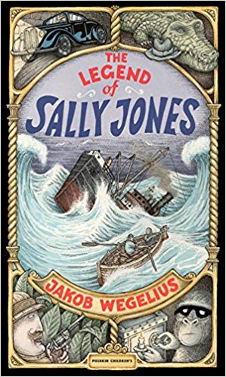

The Legend of Sally Jones

By Jakob Wegelius

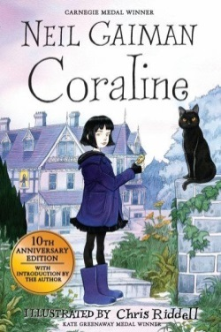
Coraline
By Neil Gaiman (Then try ‘’The Graveyard Book’ or ‘Fortunately The Milk’)

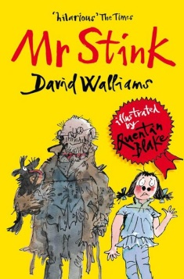
Mr Stink

By David Walliams

(Then try ‘Ratburger’)
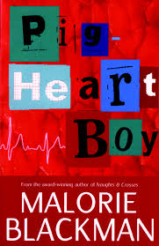
Pig Heart Boy

By Malorie Blackman

(Then try ‘Thief’)

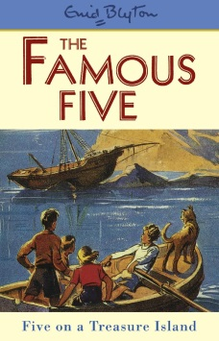
Five on a Treasure Island
By Enid Blyton

(Then try all the other ‘Five’ books)

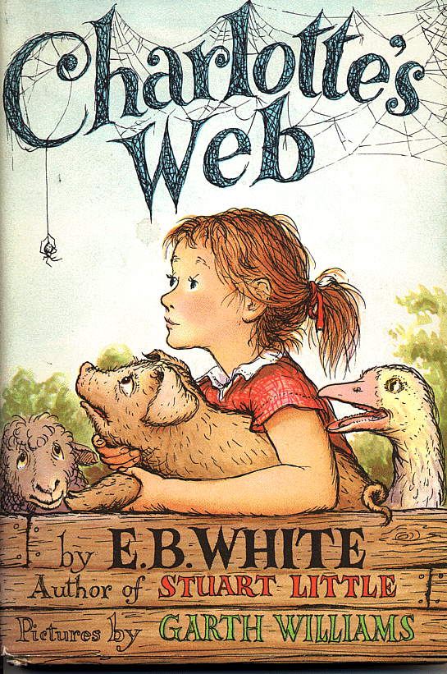

Charlotte’s Web

By E.B.White

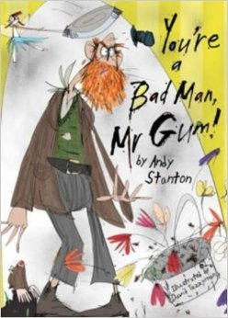
You’re a Bad Man, Mr. Gum!
By Andy Stanton (Then try all the other ‘Mr. Gum’ books)

The Illustrated Mum By Jacqueline Wilson (Then try ‘The Story of Tracy Beaker’ or )

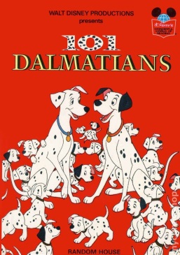
101 Dalmatians

By Dodie Smith

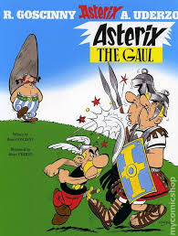

The Asterix Series

By Rene Goscinny

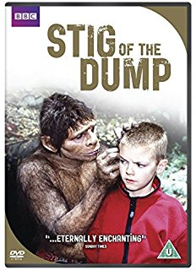
Stig of The Dump
By Clive King

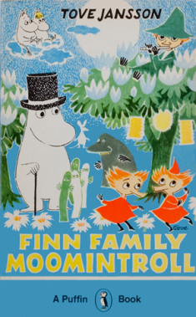
The Moomin Series

By Tove Jansson

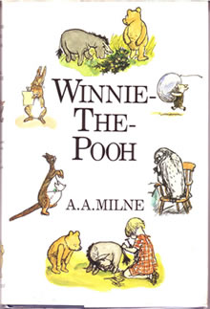
Winnie The Pooh

By A.A.Milne

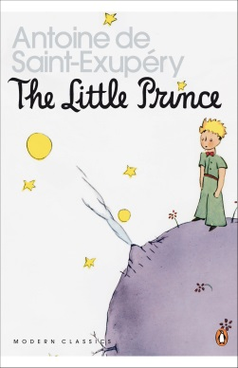
The Little Prince
By Antoine de St. Exupery

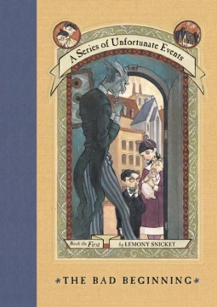
A Series of Unfortunate Events

By Lemony Snicket

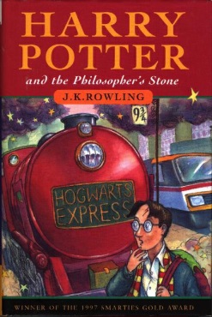
Harry Potter and The Philosopher’s Stone By J.K. Rowling (Then try all the other ‘Harry Potter’ books)
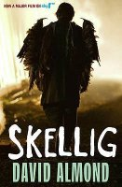
Skellig By David Almond (Then try ‘My Name is Mina’, ‘Kit’s Wilderness’ or ‘My Dad’s a Birdman’)
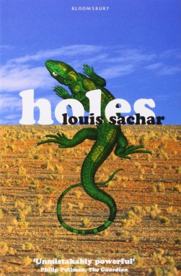
Holes

By Louis Sachar

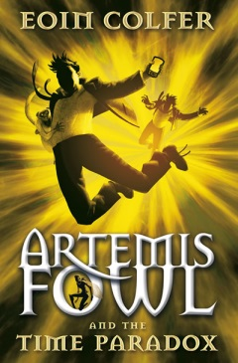

Artemis Fowl

By Eoin Colfer

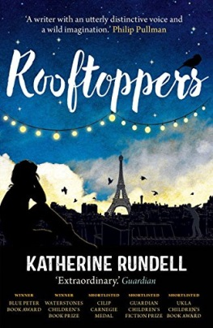

Rooftoppers
By Katherine Rundell
(Then try The Explorer)

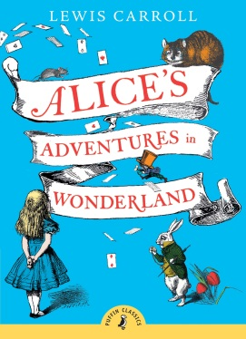
Alice in Wonderland

By Lewis Carroll

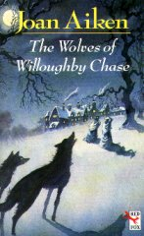
The Wolves of Willoughby Chase By Joan Aiken (Then try ‘A Necklace of Raindrops’ or ‘Midnight is a Place’)

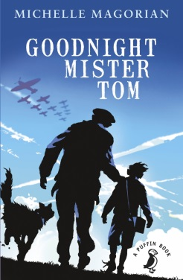
Goodnight Mr. Tom
By Michelle Magorian

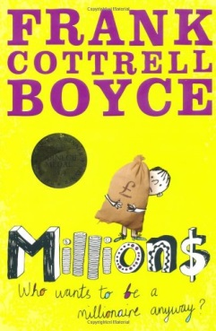
Millions
By Frank Cottrell-Boyce

(Then try ‘Framed’ or ‘Cosmic’)

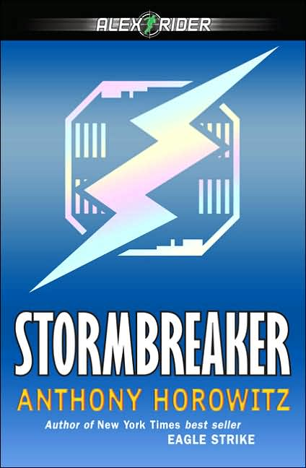
Alex Rider Series
By Anthony Horowitz (Then try ‘The Diamond Brothers Series’ or anything else he’s written)
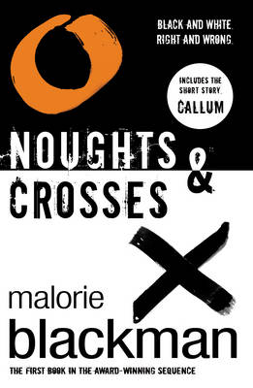
Noughts and Crosses Series
By Malorie Blackman

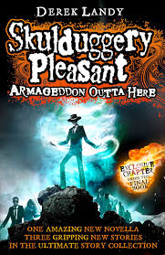
Skulduggery Pleasant (series)

By Derek Landy

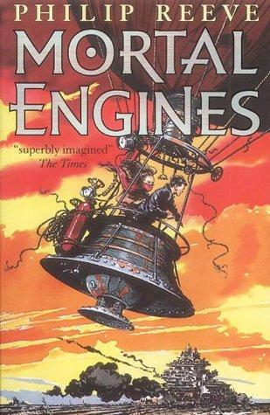

Mortal Engines

By Philip reeve

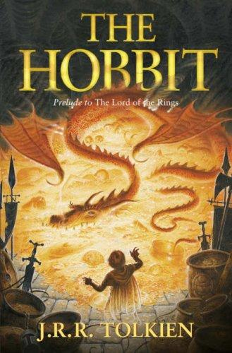

The Hobbit
By J.R.R. Tolkien
(Then try ‘The Lord
of the Rings’ Trilogy)

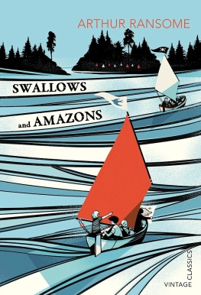
Swallows and Amazons

By Arthur Ransome

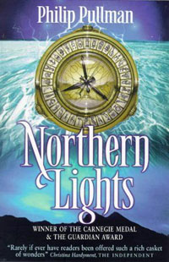
Northern Lights (His Dark Materials Series) By Philip Pullman
(Then try ‘the Ruby in the Smoke’))

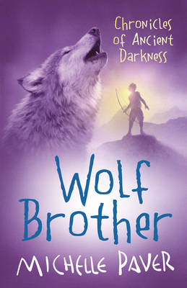
Wolf Brother (The Chronicles of Ancient Darkness series)
By Michelle Paver

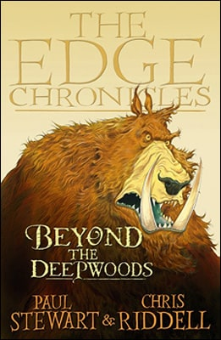
The Edge Chronicles
By Chris Riddell and Paul Stewart
(Then try ‘Barnaby Grime’ series)

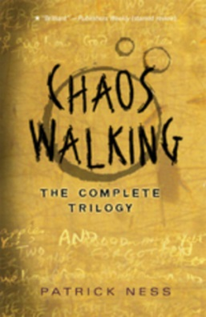
Chaos Walking (The Complete Trilogy)
By Patrick Ness

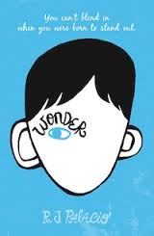
Wonder
By R.J. Palacio

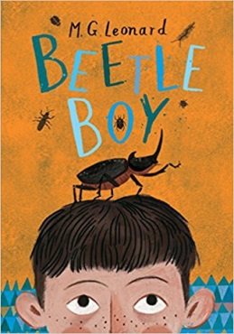

Beetle Boy

By M.G.Leonard

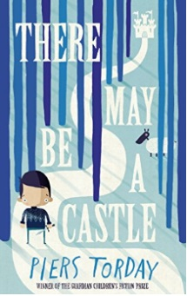
There May Be a Castle

By Piers Torday

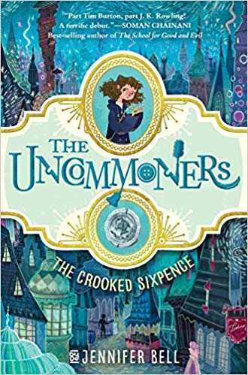

The Uncommoners
By Jennifer Bell

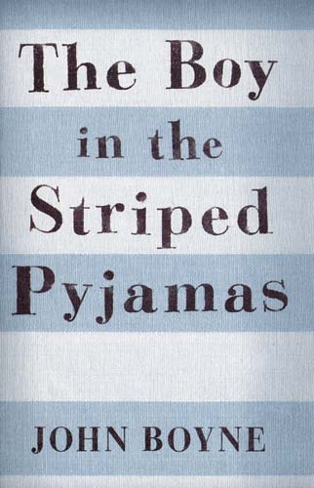
The Boy in the Striped Pyjamas

By John Boyne

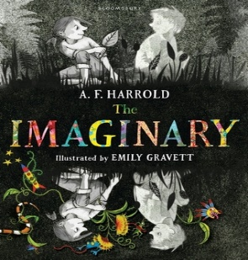
The Imaginary
By A.F.Harrold

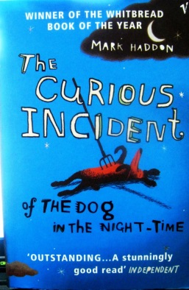
The Curious incident of the Dog in the Night-time
By Mark Haddon

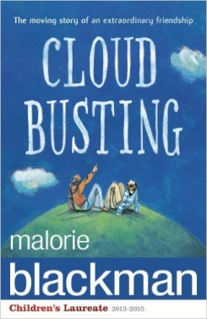
Cloud Busting
By Malorie Blackman

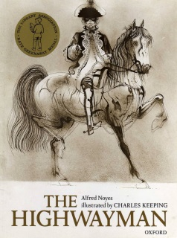
The Highwayman
By Alfred Noyes Illustrated by Charles Keeping

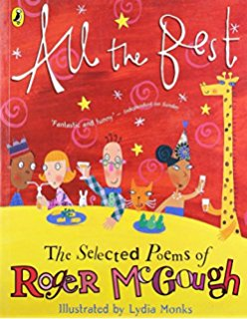
Any poetry collection…
By Roger McGough

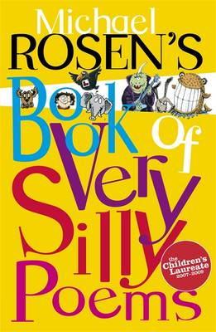
Any poetry collection…
By Michael Rosen

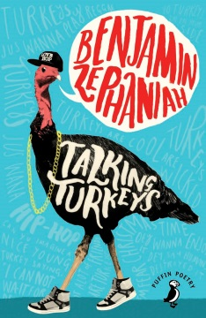
Talking Turkeys
By Benjamin Zephaniah

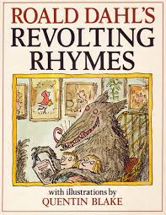
Revolting Rhymes
By Roald Dahl

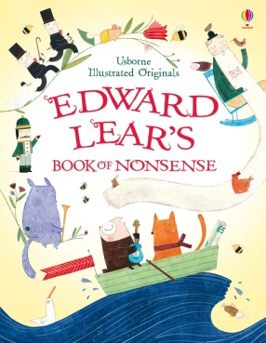
Book of Nonsense
By Edward Lear

