WANT TO PLAY? JUST ASSC
AFTER SCHOOL SPORTS COACHING
Why not let your child enjoy playing different sports in the safe environment of their own school. Use this opportunity for your child to develop a lifelong healthy and active lifestyle whilst having hours of fun learning new skills with their friends.
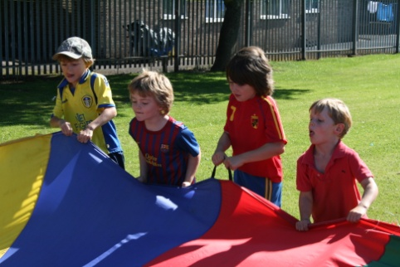

What are ASSC? Why do ASSC?
Structured programme of high quality sports tuition
Run by the school, for the school
Games based coaching curriculum to engage your child
Coaching methods that challenge, support and enthuse each child
Fun!
All money is re-invested in sporting opportunities at HBJS

Improve your child’s health, personal development and social well being
Fun activities, more opportunities, more sports
Benefits of increased motor ability, better balance and coordination
Research shows that children who are physically active achieve better academic results

Book online using
The Small Print
- Places may be limited and are offered on a first come, first served basis. There will be a maximum of 25 places per club. A text message will be sent after the payment deadline to confirm your place.
- Bookings are made for the whole half term. Clubs cannot be joined part way through the half term.
- Bookings cannot be made after the deadline has passed. (The club staffing and planning arrangements are confirmed and registers generated the day following the deadline and therefore cannot be changed).
- Dates are not guaranteed. Every effort will be made to ensure that sessions run but cancellations may occur.
- By making a payment you are confirming your consent for the club. Emergency contact and medical details will be taken from our school records. Please ensure these are kept up to date.
- Refunds are only offered if the club is cancelled by school (not in the event of sickness or any other absence).
- Behaviour issues may result in your child being excluded for the club, for one or more sessions or indefinitely. Refunds are not offered for exclusions.
- Persistent late collections may result in your child being excluded from the club.
- The schedule is reviewed each half term.

First session – w/c 5th Nov 2018 Last session – w/c 10th Dec 2018
****BOOKING DEADLINE – 4th November 2018****
Costs
Lunchtime Clubs – Free of charge (unless external provider. See below)
After School Clubs - £2.10 (unless external provider. See below)
*A reduced rate is available if you are in receipt of certain benefits. This will show automatically on sQuid if your child is eligible for Free School Meals. Please contact us if you think you may be eligible. The booking deadline still applies.
Clubs run by outside providers
The school does not administer these clubs or supervise children during the club times. Please make bookings and enquiries directly with the provider. Costs, dates and times vary to those clubs run by HBJS.
Copies of the letters/application forms for these clubs are available in school.
Day | Time | Year Group | Activity | First Session | Last Session | Provider Phone Number | Provider Email
Monday | 3.20pm – 4.30pm | All | Yoga | Please check with the provider. |  | 07816 540261 | jo@yoganaturesheffield.org.uk
Tuesday | 3.20pm – 4.30pm | All | Karate |  |  | 07952 158838 | steve@elite-karate.co.uk
Tuesday | Lunchtime |  | Tennis |  |  | 07734 746376 | jayne@apexprogramme.co.uk
Wednesday | Lunchtime | All | Squash |  |  | 07734 746376 | jayne@apexprogramme.co.uk

