Y5 Home Learning
Out – Wednesday 14th November
Back in – Tuesday 20th November
As part of Anti Bullying Week 2018 your homework is to create a poem around the theme of RESPECT. You could write a cinquain poem (as we did about Windrush), an acrostic or any other type of poem you wish (and of course, it doesn’t need to rhyme but if you want it to, that’s fine!)
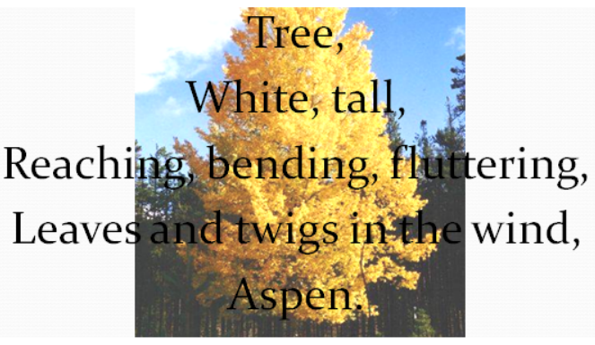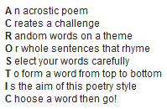
Feel free to be creative in the way you present your work!
______________________________________________________________________________________________________________________________________________________________________________________________________________________________________________________________________________________________________________________________________________________________

KIRF – Finding factor pairs
The factor pairs of 36 are
1 X 36
2 X 18
3 X 12
4 X 9
6
Using a systematic approach, find all the factor pairs of the following numbers.
100 | 54 | 64 | 90 | 42

