Y5 Home Learning
Out – Wednesday 26th September
Back in - Tuesday 2nd October
Complete the following number bond quiz as quickly as you can. Record the time it took you here:___________
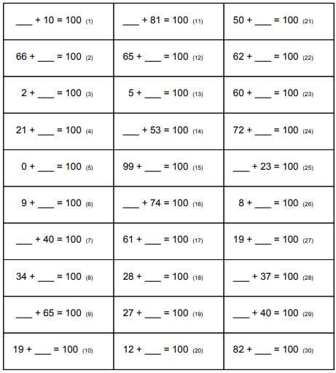
Knowing 2 digit number bonds to 100 is a key instant recall fact (KIRF) that is vital to accessing nearly all maths in Y5 and beyond.
If there is a particular area of this quiz you have found challenging, then work on this to increase your knowledge in this area. Try reciting the number bonds in the car, doing them in your head as you brush your teeth, getting an adult to randomly fire questions at you out of the blue or any other way that you find helps.

Writing
Write a paragraph describing this image. Use relative clauses and ambitious vocabulary to bring the image to life and add detail.

What a Good One Looks Like (WAGOLL)
The dragon, who was enraged and savage, breathed a stream of lava like fire into the temple. Burning ships attempted to fly away from the inferno, which devoured their homes, but many were engulfed in the flames. As the dragon readied itself to spew more fire towards the innocent villages, a small child, who was remarkably brave, stepped forward… __________________________________________________________________________________________________________________________________________________________________________________________________________________________________________________________________________________________________________________________________________________________________________________________________________________________________________________________________________________________________________________________________________
____________________________________________________________________________________________________________________

