Teaching and Learning Bulletin |  |  | October 2018  Volume 1, Issue 1
Hunter’s Bar Junior School
Points of Interest  Are you making use of the Collins Maths challenge books and the Deepening Maths tasks recently distributed by Dave?  They provide ways to deepen and widen the understanding of the early graspers in your classes.  Please see David for any further support how to use these.  Word to the wise  CPD – it’s not good enough just to listen. It’s what you do with it that counts!  For further clarification on any of the points addressed in this bulletin, please see Alex or Michael  If you would like to contribute to this T and L bulletin, please contact Alex.  Who to follow on Twitter:  @teachertoolkit  Ross Mcgill offers a wealth of tips, resources and links to satisfy the needs of every inquisitive practitioner about the science of learning, CPD, leadership, well-being and then some!  Contents  1. Resource of the Week  2. SDIP priorities  3. Current Focus in the Classroom  4. Recommended Reading  5. Upcoming CPD  6. Education in the News | Take charge of improving your own practice!  Make use of this regular bulletin, filled with current and relevant information for all staff at Hunter’s Bar Junior School.
3. Current Focus in the Classroom
2. SDIP Priorities 2018-19
1. Resource of the Week
 | https://mathsbot.com/  A fantastic online resource that helps practitioners manipulate base 10, counters, geo boards, counting sticks, bar models, and much, much more! Get it used!  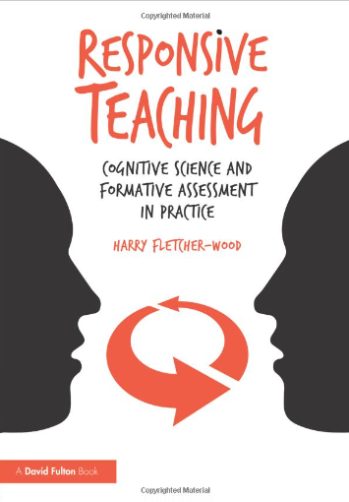  Teachers are currently reading chapter 1 and 2 of ‘Responsive teaching’ by Harry Fletcher-Wood, ready for TLC 2 after the October break, when we will be studying cognitive load theory and how it translates into practice in the classroom.  4. Recommended Reading and podcasts | 5. Forthcoming Professional Learning  - Developing and embedding effective writing pedagogy  - Developing and embedding talk/vocabulary across the curriculum  - Implementing a Maths mastery curriculum through the MNP approach  Wed 3rd October – Safeguarding - PREVENT  Wed 10th October - EPIC curriculum CPD Teachmeet  Tues 16th October - PDM EPIC curriculum reflection time  Wed 17th October – (Twilight– developing modelled writing in the classroom  Wed 24th October – EPIC curriculum planning time | Retrieval Practice.  We are evaluating the impact of low stakes retrieval quizzing on our target pupils this half term. Use the TLC peer observation feedback script to ensure a structured follow-up meeting!  Labour pledges end to academisation  Angela Rayner is to set out details of Labour's education policies.  ‘Tides are turning against teaching to the test’  More people are waking up to the fact that teaching to the test is not a long-term solution, says Daisy Christodoulou  Full articles on tes.com/news  6. Education in the News

